IQP Writing Guide:

From Proposal to Final Report

Author’s Note and AI Disclosure: This guide draws on my experience teaching ID2050 and advising IQP projects since 2018, as well as writing guides, assignments, examples, and other instructional materials I have developed or adapted from materials generously shared by colleagues. In developing this guide, I used Microsoft CoPilot to help synthesize these materials, identify and address inconsistencies that had emerged over time, and improve the coherence, organization, and consistency of guidance across the ID2050 proposal and IQP process. While CoPilot was useful in the development of the guide, I am the author and take responsibility for its final content, including how the materials were selected, adapted, organized, and revised to reflect my teaching approach and the goals of ID2050 and the IQP.

Table of Contents
Chapter 1 - Writing Through the IQP Process 9
1.1 From Proposal to Final Report 9
Research Proposal 9
IQP Final Report 9
1.2 Writing Is Part of the Research Process 9
1.3 Writing as a Team 10
1.4 How to Use This Guide 11
1.5 Planning Your Next Steps 11
Chapter 2 - Building Your Research Story 12
2.1 Introduction 12
What is the purpose of the introduction? 12
Writing Your Proposal Introduction 13
Writing Your Final Report Introduction 13
Planning Your Next Steps 13
2.2 Background Chapter 15
What is the purpose of the Background Chapter? 15
Researching for your Background Chapter 15
Synthesizing Your Research 16
Organizing Your Background 16
Related Guidance 18
Writing Your Proposal Background 19
Writing Your Final Report Background 19
Planning Your Next Steps 19
2.3 Methods Chapter 20
What is the purpose of the Methods Chapter? 20
Developing Your Research Design 21
Project Goal 21
Research Objectives 21
Research Questions 22
Choosing Your Methods 22
Connect Research Questions to Methods 23
Planning for Data Analysis 24
Triangulating Your Research 25
Considering Research Limitations 26
Research Ethics and the IRB 27
Write Your Methods in Active Voice 29
Writing Your Proposal Methods 30
Writing Your Final Report Methods 30
Organizing and Writing Your Methods Chapter 31
Related Guidance 34
Chapter 3 - Making Sense of and Communicating What You Learned 35
3.1 Findings 35
What is the purpose of the Findings Chapter? 35
Data Are Not Findings 35
Moving from Analysis to Findings 35
Findings Are Not Always Problems 36
Organizing Your Findings 36
State the Finding, Then Support It 37
Use Evidence Selectively 37
Triangulate Your Evidence 38
Acknowledge Limitations and Alternative Interpretations 38
Background, Methods, or Findings? 38
Planning Your Findings Chapter 39
3.2 Recommendations 40
What is the purpose of the Recommendations Chapter? 40
State Recommendations Directly 40
Make the Audience Clear 41
Connect Recommendations to Evidence 41
Provide a Path Toward Implementation 41
Prioritize When Appropriate 42
Recommendations for Future Research 42
Planning Your Recommendations 43
3.3 Conclusion 43
What is the purpose of the Conclusion? 43
Move from the Project to Its Larger Significance 43
Keep the Conclusion Meaningful 44
Chapter 4 - Completing the Proposal and Final Report 45
4.1 What Goes in Each Document? 45
4.2 Completing Your ID2050 Research Proposal 47
Proposal Conclusion 47
Proposal Front Matter 47
Title Page 47
Authorship Table 48
AI Use Statement 48
Table of Contents, List of Figures, and List of Tables 49
References 49
Proposal Appendices 49
Assembling Your ID2050 Research Proposal 50
Related Guidance 51
4.3 Completing Your IQP Final Report 51
Final Report Front Matter 51
Cover Page and Title Page 51
Abstract 52
Acknowledgments 54
Meet the Team 54
Authorship Statement 54
AI Use Statement 54
Table of Contents, List of Figures, and List of Tables 54
References 55
Appendices and Supplemental Materials 55
Assembling Your IQP Final Report 56
Related Guidance 56
Chapter 5 - Documenting Your Project and Designing Your Report 58
5.1 Designing for Your Reader 58
5.2 Figures, Tables, and Data Visualization 61
5.3 Formatting and Document Mechanics 63
5.4 Citations and References 66
5.5 Editing and Proofreading Your Report 69
5.6 Final Document Checklist 70
Chapter 6 - Sharing and Extending Your Project 73
6.1 Submitting Your Final Report to e-Projects 73
6.2 Printing Your Final Report 73
6.3 Project Recognition Opportunities 73
WPI President's IQP Awards Recognition 73
The Forum on Education Abroad: Award for Academic Achievement Abroad 73
Harvard Scholarship & Social Justice Undergraduate Research Conference 74
WPI Annual Sustainability Project Competition 74
6.4 Publication Opportunities 74
Undergraduate Journal of Service Learning & Community-Based Research 74
Resources 75
Design Resources 75
Examples of Exceptional Reports 75
Examples of Exceptional Findings and Recommendations Chapters 75
APA and Citation Resources 75
Appendix A: Cover Page Examples 76
Appendix B: Required WPI Title Page for Final Report 77
Appendix C: Example Final Report Authorship 78
Appendix D: Example Meet the Team Pages 79
 79

Chapter 1 - Writing Through the IQP Process

1.1 From Proposal to Final Report
The research proposal you develop in ID2050 and the final report you complete at the end of your Interactive Qualifying Project (IQP) are connected pieces of the same research process. They serve different purposes and are written at different points in the project, but the thinking and writing you do for one provides the foundation for the next.

Research Proposal
During ID2050, your team is preparing to conduct a research project with your host organization. You are learning about the project and its context, considering the perspectives of your project host and other stakeholders, identifying what you know and what you still need to learn, and developing a research approach that will allow you to successfully complete your project. Your research proposal captures your team's best understanding and plan at the start of your IQP.

IQP Final Report
During your IQP, you put the plan from your proposal into practice. You work with your host organization and local community, collect and analyze information, encounter unexpected challenges, and develop a deeper understanding of the project. Your final report communicates what you actually did, what you learned, and what you recommend based on the evidence you collected.

ID2050 and the Proposal | IQP Final Report
What do we understand now?  What do we need to learn?  How do we plan to learn it? | What did we do?  What did we learn?  What can we reasonably conclude?  What do we recommend?

The proposal gives you a strong plan to begin your IQP, but you should expect that your plan will change as you begin your project. Research rarely unfolds exactly as planned, particularly when you are working on complex problems with organizations and communities. This does not mean that your proposal was wrong. The proposal was your best plan for how to approach your project given the information you had at the time.

1.2 Writing Is Part of the Research Process
It can be tempting to think of the proposal as something you write at the beginning of the project and the final report as a product that you create at the end. In truth, the proposal should guide your team throughout the entire research project, and the final report should be something you develop throughout the project term.
When your team tries to explain why a problem matters, you may discover that you do not yet understand part of the context and you need to conduct additional background research. When you try to write a research question, you may realize it is too broad to answer, and you need to narrow the scope of your project. When you use a particular method in the field, you may realize it will not provide the information you need, and you may need to adjust your approach. When you try to explain a finding, you may discover that you do not have enough evidence to support your conclusions.
This is all part of the research process, and it is also why the final report is not simply your proposal with the verbs changed from future to past tense.
Throughout the project term, you will return to writing you have already done and ask whether it still represents your project. Sometimes you will make relatively small revisions. Other times you may need to rethink a section because the direction of the project or your understanding of the project has changed.
This guide will help you to draft your initial proposal and to critically evaluate and revise it as you work to complete your final report.

1.3 Writing as a Team
Your proposal and final report are team documents. That does not mean every sentence needs to be written by every team member, nor does it mean the most efficient way to write is to sit together and compose every paragraph collectively.
It makes sense that your team will divide some of the initial research and drafting. But dividing the writing is not the same as dividing responsibility for the report.
Everyone on the team should understand the argument the report is making, the research methods you are using, the evidence you collected, and the conclusions and recommendations you make.
This means that team writing requires more than combining independently written sections into one document. As you revise together, pay attention to:
- whether sections make the same assumptions;
- whether you are using important terms consistently;
- whether ideas build logically from one section to another;
- whether there is repetition because everyone is explaining the same concepts in multiple places;
- whether there are gaps because everyone thought someone else was explaining something;
- whether the document sounds like one team telling one coherent research story.

1.4 How to Use This Guide
You do not need to read this guide from beginning to end every time you work on your report. Think of it as a working guide that your team will return to throughout ID2050 and your IQP.
Each major section of the guide begins by explaining what that part of the report is trying to accomplish. From there, the guide will help you develop that section for your proposal and, where appropriate, return to it during IQP to transform it into your final report.
I have structured this guide to include three recurring elements:
Writing Your Proposal
These sections focus on the decisions your team needs to make while developing your research proposal in ID2050. At this stage, you are explaining what you understand, what you need to learn, and what you plan to do.
Writing Your Final Report
These sections ask you to return to your earlier work after you have conducted the research. The goal is not simply to update what you wrote. Consider what you now know, what has changed, and what your final report needs to include.
Planning Your Next Steps
These are questions for your team to work through together. They are not a checklist or another assignment. Some will help you get started. Others will help you make decisions while you are writing or determine how your thinking needs to change as you move from proposal to final report.

1.5 Planning Your Next Steps
As you begin working on your project, use these questions to identify what your team understands, what you still need to figure out, and how you will approach the work together. Before you move on to the next section, consider these questions as a team:
- What do we currently understand about our project, and what are we still trying to understand?
- Who will need to read and use our work, both during ID2050 and during the IQP?
- What does our project host need from this project? Are there other stakeholders who may need something different?
- How will we work as a team so that our proposal and final report represent shared thinking rather than separate pieces written by different people?

Chapter 2 - Building Your Research Story
Your ID 2050 research proposal has three main chapters: Introduction, Background, and Methods. Together, these chapters tell the story of your project and your plan for how you will conduct your research. During your IQP, you will revise these chapters as your project develops to add additional background context, document your actual research process, and ensure your final report accurately represents the project you completed.

2.1 Introduction

What is the purpose of the introduction?
The Introduction gives readers their first understanding of your project. It should help them understand the larger societal context, the specific problem or opportunity your project addresses, why the project is needed, and what your team will do about it.
For most projects, this can be accomplished in about five paragraphs, although some projects will need more. Rather than focusing on the number of paragraphs, think about the five moves your Introduction needs to make.
Move 1: Establish the Broader Context
Begin with the larger societal context connected to your project. What is happening in the world, country, region, field, or community that makes this project important? Use research or evidence where appropriate to help readers understand the significance of the issue.
Move 2: Identify the Local Problem or Opportunity
Narrow the focus to the specific problem, need, or opportunity your project addresses. What does the larger issue look like in your local context? Who is affected? This is often where you will briefly introduce your project host and their connection to the issue.
Move 3: Explain What Is Already Known or Being Done
Briefly establish what is already known about the problem and what has already been done to address it. This might include previous research, programs, policies, practices, or approaches. You will develop these ideas more fully in your Background. Here, include what your reader needs to understand the current situation.
Move 4: Identify What Still Needs to Be Understood or Addressed
Given what is already known or being done, what is still missing, unresolved, or not working well enough? For an IQP, this does not have to be a gap in academic research. It may be a practical gap in knowledge, understanding, practice, or capacity. This is what creates the need for your project.
Move 5: Introduce Your Project and Its Purpose
Finally, explain how your project responds to that need. Introduce your project goal and the major objectives that will guide your work. You do not need to explain the details of your research methods here. Your reader simply needs to understand what your team is trying to accomplish and how it connects to the problem you have established.
Together, the five moves should create a logical progression. You will end the Introduction with a brief roadmap that helps readers understand where the report will go next.

Writing Your Proposal Introduction
Your proposal Introduction represents your team's best understanding of the project during ID2050. You may understand some parts of the project before others, so expect to return to the Introduction as you conduct more background research, talk with your project host, and refine your project goal and objectives. By the end of the Introduction, your reader should understand why the project is needed and what your team plans to accomplish.

Writing Your Final Report Introduction
When you return to the Introduction during IQP, do not simply change the verbs from future to past tense. Return to the five moves and ask whether they still tell the right story. Your understanding of the context, problem, stakeholders, or project itself may have changed. Revise the Introduction to reflect what you understand now and the project you completed.
Pay particular attention to Moves 4 and 5. Does the need you identified in the proposal still make sense based on what you learned? Does your project goal accurately represent the work you ultimately completed? Update the roadmap as well so that it reflects the organization of your final report.

Planning Your Next Steps
Use the five moves to sketch the structure of your Introduction before you begin drafting. You do not need complete sentences. Jot down the main ideas, evidence you might use, and anything your team still needs to figure out.
Introduction Move and Questions to Guide Your Planning | Your Ideas
1. Broader Context: What larger societal context does our reader need to understand? Why does it matter? What evidence or information might help establish its importance?
2. Local Problem or Opportunity: What is the specific problem, need, or opportunity our project addresses? What does our reader need to know about the local context and our project host's connection to the issue?
3. What Is Already Known or Being Done: What does our reader need to know about what has already been learned, tried, or done? What research, programs, policies, practices, or other approaches are most relevant?
4. What Still Needs to Be Understood or Addressed: What is still missing, unresolved, unknown, or not working well enough? What does our project host or community still need to know, understand, develop, evaluate, or address?
5. Our Project: How does our project respond to the need we identified? What are we trying to accomplish? What is our project goal? What are our major objectives?
Look at the Introduction as a Whole: Can we trace a clear path from the larger issue to the need for our project? Where does the story make a jump? What do we still need to research, discuss, or figure out?

2.2 Background Chapter

What is the purpose of the Background Chapter?
The Background Chapter provides the research and context needed to understand your project. Depending on the project, this may include research about the larger issue, the local context, important stakeholders and their perspectives, previous efforts to address the problem, and approaches used in other places or contexts.

You may also hear this chapter referred to as a literature review. In this guide, I use the term Background, but you can think of Background and literature review as referring to the same general part of your research report. In both cases, the goal is to bring together and synthesize existing research and knowledge related to your project.

The purpose of the Background can change as you move from your ID2050 proposal to your final report. During ID2050, the process of researching the Background is an important part of how your team prepares for the project. You will likely begin with limited knowledge about the topic, local context, stakeholders, or approaches others have used to address similar problems. Background research helps your team come up to speed on the project and develop the knowledge you need to make informed decisions about your research. You then use what you have learned to write a formal Background chapter.

By the time you write your final report, you have developed a much deeper understanding of the project and the purpose of the Background shifts toward your reader. In your final report, your Background will provide readers with the context they need to understand your project, research, findings, and recommendations. This is why you will revisit and revise your Background during your IQP term.

Purpose of the Background Chapter
ID2050 Proposal | IQP Final Report
Help your team come up to speed on the topic and develop the knowledge needed to plan and conduct your research. | Help your reader understand the context and existing knowledge needed to make sense of the project and the research you completed.

Researching for your Background Chapter
Developing your Background is an iterative process. You will not know everything you need to research at the beginning, and you do not need to finish your research before you start writing. What you learn will lead to new questions, and writing will often help you identify gaps in your understanding.

The Research and Writing Process

As you work through this process, look for patterns, different perspectives, areas of agreement and disagreement, previous approaches, and questions that remain unresolved. The goal is to move from collecting information to making sense of what you are learning. You will probably move back and forth among these steps rather than following them once in order. That is part of the research and writing process.

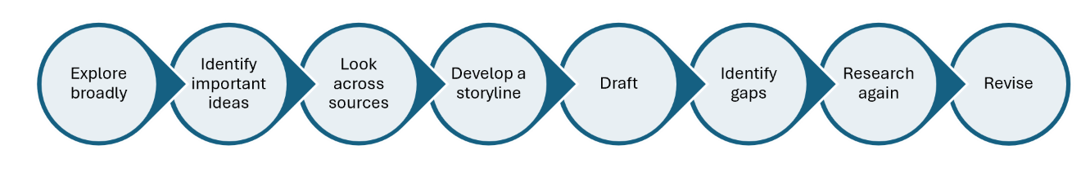

Synthesizing Your Research
A strong Background is organized around ideas rather than individual sources. Your sources provide evidence for the ideas you are developing, but the sources themselves should not determine the organization of the chapter. As you write, look across your research. Where do sources agree or disagree? What patterns emerge? What different perspectives are represented? What does the research collectively help you understand about the issue?

Instead of writing a paragraph about one source followed by a paragraph about another, bring information from multiple sources together to develop the ideas your reader needs to understand.
The goal is to move from reporting what individual sources say to synthesizing what the research helps us understand about the issue.

Organizing Your Background
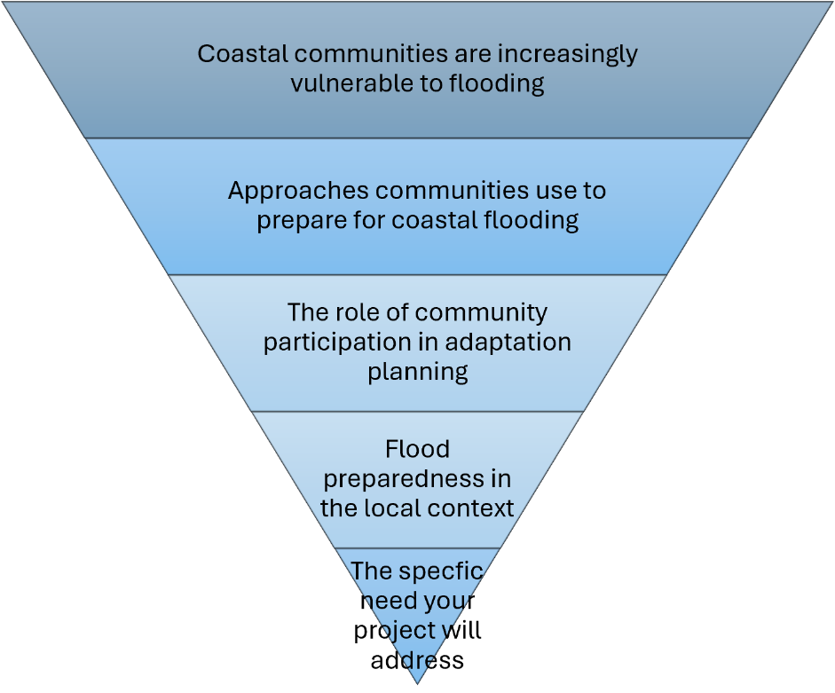
There is no single correct way to organize a Background chapter. Choosing the structure is one of the important decisions your team will make. Think about the story your Background needs to tell. What does your reader need to understand first? What information builds on that understanding? How should the chapter eventually lead toward the research your team will conduct?

The following structures are useful starting points, but they are not required formats.

The Funnel
A funnel moves from the broader issue toward the specific context of your project. A funnel works well when your reader first needs to understand a larger issue before they can understand the specific local problem. The important question is not simply whether you can move from broad to narrow.

Ask:
Does understanding each section help the reader understand why the next section matters?

The Sandwich
Sometimes readers need to understand the local context before the broader research will make sense. In this case, a sandwich structure may work better.

The community and its current waste-management challenge
↓
Research on household waste behaviors
↓
Approaches used in other communities
↓
What is known about participation and behavior change
↓
What this research suggests for the local project

Here, you begin with the specific local context, step back to consider broader research and examples, and then return to the project context with a stronger understanding of it. A sandwich structure can be useful when the project is strongly grounded in a particular place, organization, or community and readers need that context to understand why the broader research is relevant.

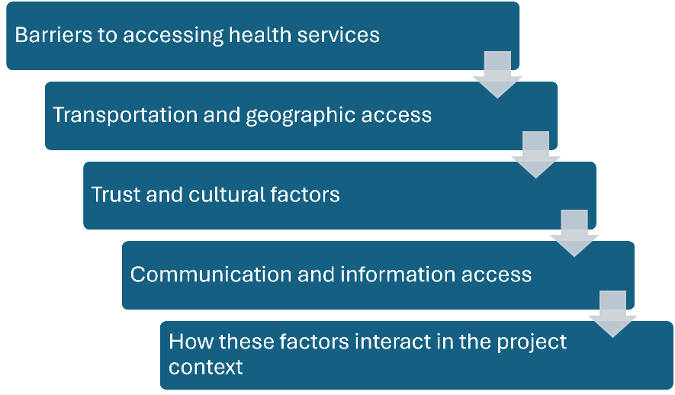
A Thematic Structure
For some projects, there is no obvious broad-to-narrow sequence. Instead, readers may need to understand several connected dimensions of a problem.

A thematic structure can work well when several related issues or perspectives need to be understood together.

Other Organization Options
Funnel, sandwich, and thematic are potential structures and not firm rules for how to organize your background chapter. Your project may need a variation, a combination of these approaches, or a different structure entirely. Whatever approach you choose, your team should be able to explain the logic behind the flow, and you should ensure that your writing includes transitions that help the reader understand the connection as you move from one section to the next.

You can use descriptive section headings to help make that structure visible. Your headings should tell readers something about the ideas in the section rather than simply label broad categories such as Previous Research or Project Host. The Background should ultimately bring your reader to the point where your own research follows logically from what is already known and what still needs to be understood.

Related Guidance
Several other parts of this guide address research and writing skills that you will use when developing your Background. You can refer to these sections as needed when you are writing your background chapter.
- Quoting, Paraphrasing, and Summarizing: Section 5.4
- Citations and References: Section 5.4
- Using AI in Research and Writing: Section 5.4

Writing Your Proposal Background
The background chapter in your proposal represents what your team understands before beginning your IQP. The process of conducting background research should help you come up to speed on the major issues surrounding your project and make informed decisions about the research you plan to conduct. By the end of ID2050, your Background should formally synthesize what your team has learned and provide a strong foundation for your proposed research.

Writing Your Final Report Background
Your proposal Background gives you a strong starting point for the final report, but it will need to be revisited and revised before you can include it in your final report. The purpose of your background in your final report is to provide your reader with enough context to understand the project you completed. To revise your background chapter, you may need to:
- Keep material your readers still need to understand the project.
- Add research or context you learned during IQP.
- Remove information your team needed to learn in ID2050 but your reader does not need.
- Revise explanations you now understand differently.
- Reorganize the chapter if the original structure no longer fits the completed project.

Your final Background Chapter should represent what your team understands about the project now, not simply what you knew when you wrote the proposal. As you revise, also pay attention to the difference between Background and Findings. Both may contain information that helps readers understand your project, but the key difference is often where the knowledge came from. The background draws primarily on knowledge that already existed, while findings present knowledge your team generated through your research.

 | Background | Findings
Where does the knowledge come from? | Existing research, reports, documents, and other knowledge produced by others | Evidence your team collected and analyzed through your project research
Why is it included? | To give readers the context and existing knowledge they need to understand the project | To show what your research helped you learn and how it answers your research questions

Planning Your Next Steps
Before you begin drafting your Background, your team needs to decide how you will organize the chapter. Take a step back from the individual sources and topics you have been researching and think about the story your Background needs to tell. Use these questions to plan the organization of your chapter:
- What are the major ideas your reader needs to understand?
- How are those ideas connected?
- What does your reader need to understand first for the later sections to make sense?
- Which ideas belong together in the same section?
- Would a funnel, sandwich, thematic, or another structure work best for your project?
- Where should the Background leave the reader so that your own research follows logically?

Then sketch a possible outline for your chapter. Focus first on the ideas and the order in which your reader needs to encounter them. Don't worry about perfect section headings yet. Your outline can continue to change as your team's understanding develops.

Background Section | What is the purpose of this section? | Why does this section appear in this order?
Beginning:
Next:
Next:
Next:
Leading to our research:

2.3 Methods Chapter

What is the purpose of the Methods Chapter?
The Methods Chapter explains how your team will conduct, or conducted, the research needed to accomplish your project goal. It connects what you are trying to accomplish with what you need to learn and the methods you will use to learn it. Think of your Methods Chapter as an instruction manual for your research. In your ID2050 proposal, it provides the plan your team will use to guide your research during IQP. In your final report, it documents what you actually did in enough detail that another researcher could understand and repeat your approach.

A strong Methods Chapter explains three things throughout:
WHAT you want to learn.
HOW you will learn it.
WHY this approach makes sense.

In your proposal, the Methods Chapter is your research plan. In your final report, it records the research you actually conducted.

 | ID2050 Proposal | IQP Final Report
Purpose of the Methods Chapter | Provide a detailed research plan that will guide your team's work during IQP. | Document what your team actually did and how you did it so readers can understand, evaluate, and potentially repeat your research.

Developing Your Research Design
A strong Methods Chapter begins before you select your methods. It can be tempting to begin by saying, "we will conduct interviews" or "we will create a survey." But selecting a method should not be the first step. First decide what you are trying to accomplish and what you need to learn. Then decide the methods you will use to learn it.

Your research design should create a logical connection between your:
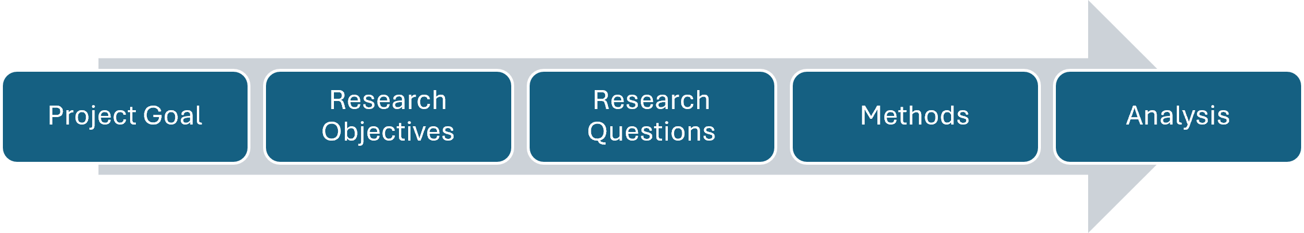
Each part should help you make decisions about the next.

Project Goal
Your project goal describes what your team ultimately hopes to accomplish through the project. It should respond to the problem or opportunity you established in your Introduction and Background. Your goal tells us where the project is going. It should be broad enough to capture the overall purpose of your project but specific enough that your team can realistically accomplish it during your IQP. A goal might generally take this form: To [accomplish something] for/with [project host or community] in order to [larger purpose]. The exact wording will depend on your project.

Research Objectives
Your research objectives identify the major areas your team needs to investigate or understand in order to accomplish your project goal. Objectives should focus on what you need to learn, understand, assess, evaluate, explore, or determine, rather than simply listing the activities you plan to complete.

For example:
Objective: Understand residents' current transportation behaviors and barriers to using public transit. (This is something you need to learn in order to accomplish your goal.)

is different from: Conduct interviews with residents. (Conducting interviews is a method your team might use to accomplish the objective.)

It is also different from: Develop a transportation guide.(This might be a deliverable produced as a result of the project.)

Keeping these distinctions clear will help you develop a research plan in which every activity has a purpose.

Research Questions
Research questions make your objectives more specific. They identify the questions your team needs to answer in order to accomplish each objective.

For example:
Objective: Understand residents' current transportation behaviors and barriers to using public transit.
Possible research questions might include:
- How do residents currently travel?
- What barriers prevent residents from using public transit?
- Do those barriers differ among stakeholder groups?

Research questions should be specific enough that you can begin asking: What information would allow us to answer this question? That question provides the bridge between your research questions and your methods.

Start Planning Your Research Goal, Objectives, and Research Questions
Before deciding which methods to use, take some time with your team to complete the table below, working from your project goal toward the information you need and where or from whom you might obtain that information.
Project Goal | Research Objective | Research Questions | What information do we need? | Who or what can provide it?
 | 1.
 | 2.
 | 3.
Look across your plan before moving on to methods.
- Does each objective help you accomplish your project goal?
- Do your research questions help you accomplish the objective?
- Do you know what information you would need to answer each question?
- Are any of your objectives actually methods, activities, or deliverables?
Once you know what you need to learn and what information you need, you are ready to decide what methods you will use to collect it.

Choosing Your Methods
A research method is the approach you use to collect the information needed to answer your research questions. Depending on your project, your methods might include interviews, surveys, focus groups, observation, archival research, comparative analysis, or other approaches appropriate to your research questions. Your project should use multiple methods. Different methods can help you answer different questions, gather information from different sources, or provide different perspectives on the same issue.

Selecting a method is only the beginning. Your Methods Chapter needs to explain what you will do, how you will do it, and why that approach makes sense.

WHAT will you do?
Explain the method and what you hope to learn from it. Be specific about the information you are trying to collect and its relationship to your research question or objective.

HOW will you do it?
Explain how you will actually implement the method. Depending on the method, this may include:
- who will participate in the research;
- how participants, locations, documents, or other sources will be selected;
- how participants will be recruited;
- where or how the research will take place;
- what questions, protocols, instruments, or measurements you will use;
- how much information you intend to collect;
- how you will record, organize, and manage the information; and
- how you will analyze the information once it is collected.

The details will be different for different methods. Interviews will require different information than observations, surveys, or archival research.

WHY is this the right approach?
Do not assume that the reason for choosing a particular method will be obvious to your reader. Explain why the method is appropriate for the information you need and the context in which you will be working. Consider:
- Why will this method help answer your research question?
- Why are these participants, locations, documents, or other sources appropriate?
- Why are you collecting the information you propose?
- Have other researchers successfully used a similar approach? When useful, cite methodological guidance or previous studies to support your research choices.
- Are there characteristics of the local context or population that influenced your decision?
- What are the strengths and limitations of the method?
Your justification should show that the method is an intentional research decision rather than simply a convenient activity.

Connect Research Questions to Methods
Use your research questions to work through the major decisions for each method before you begin writing the chapter.
Research Question | Information Needed | Source of Information | Method | How will we collect it? | Why does this method make sense?
A method may help answer more than one research question, and you may use more than one method to answer the same question. What matters is that you can explain the connection between what you need to learn and how you plan to learn it.

Planning for Data Analysis
Your research design should include a plan for how you will make sense of the information you collect. Collecting data is only the beginning, you also need to analyze that data to answer your research questions.

During ID2050, you may not yet know exactly how you will analyze your data. That is okay. Qualitative data analysis is an iterative process, and your approach will continue to develop as you learn more about data analysis and begin working with the data you actually collect. At the proposal stage, however, you should have a reasonable plan for the type of analysis you expect to use. Depending on your methods and the type of data you collect, you might:
- code qualitative data from interviews, focus groups, observations, or open-ended survey questions to identify patterns and themes;
- summarize survey data using counts, percentages, or comparisons among groups;
- organize observational data into categories to identify patterns across settings;
- compare programs, policies, technologies, or potential solutions using defined criteria; or

Your proposed analysis strategy can be relatively simple, but it should be specific enough to show that you have thought about how you will turn the information you collect into evidence that can help answer your research questions. For qualitative research in particular, analysis is often iterative. You may begin by coding the data to identify important or recurring ideas, combine related codes into categories, and eventually develop larger themes that help answer your research questions. You do not need to know what those codes or themes will be before you conduct the research. They will develop as you work with your data.

Data Analysis in Your Final Report
By the time you write your final report, you can be much more specific about your analysis because you know what data you collected and what you actually did with it. Return to the analysis plan in your proposal and replace what you planned to do with what you actually did. Depending on your research, this might include explaining:
- how you prepared and organized your data;
- how you developed and applied qualitative codes;
- how codes were combined into categories or themes;
- what quantitative calculations or comparisons you conducted;
- what criteria you used to compare cases, programs, policies, or possible solutions;
- how you compared evidence across participants, stakeholder groups, or methods; and
- how your analysis helped you answer your research questions.

At the final report stage, students can often be confused about what aspects of the data analysis belong in the Methods Chapter versus the Findings Chapter. Remember the Methods Chapter is about what you did. So, when it comes to data analysis, your Methods Chapter explains how you analyzed the data (your procedures for analyzing it), and the Findings Chapter explains what that analysis helped you learn (your findings).

Methods Chapter | Findings Chapter
Your procedures for analyzing data | What you learned from your data (your findings!)

Triangulating Your Research
Many IQPs rely on relatively small samples and primarily qualitative data. One way to strengthen your research is through triangulation, or using multiple methods or sources of evidence to investigate the same research question. For example, imagine your team is trying to understand barriers to participation in a community program. You might:
- interview community members about their experiences;
- survey a broader group about common barriers;
- observe how people interact with the program; and
- review participation records or other existing data.

Each method provides a different perspective on the same question. If your interviews, survey, observations, and existing data point toward similar conclusions, you have stronger evidence to support a finding. If they do not agree, that is also important. Differences in the evidence may reveal something your team needs to investigate further or may suggest that the situation is more complicated than you initially thought.

Triangulation does not mean that every research question needs three methods, or that simply using more methods makes your research stronger. The goal is to collect different forms of evidence that allow you to compare, confirm, or complicate what you are learning. As you develop your research design, ask:
- Which of our research questions would benefit from more than one source of evidence?
- Can we investigate the same question using different methods?
- Are we gathering perspectives from different people or stakeholder groups?

Planning for Triangulation
For research questions where triangulation would strengthen your research, map out the different evidence you could collect.
Research Question | Evidence from Method/Source 1 | Evidence from Method/Source 2 | Evidence from Method/Source 3
The goal is not to fill every box. Instead, use the table to identify where multiple forms of evidence could strengthen your ability to answer an important research question.

Considering Research Limitations
All research has limitations. A research limitation is something about your research design, data collection, sample, or analysis that affects what you can reasonably conclude from your evidence.

Limitations in Your Proposal
During ID2050, you will not know all of the limitations your research will ultimately have. You can, however, anticipate some limitations as you design your methods. For example, consider:
- Will your sample be relatively small?
- Might it be difficult to reach some groups of participants?
- Are there perspectives your method may not capture?
- Could language or cultural differences affect your research?
- Could the way you ask questions influence the responses you receive?
- Are there practical limitations on how much data you can collect during the project term?

Thinking about potential limitations before you begin your research gives you an opportunity to strengthen your design. You might revise a data collection tool, change how you recruit participants, or use another method to triangulate your evidence. In your proposal, you can discuss anticipated limitations as part of the relevant method and explain how you plan to address or reduce them when possible. Alternatively, you could discuss limitations as a subsection of your Methods Chapter.

Limitations in Your Final Report
By the end of your IQP, you will have a much clearer understanding of your research limitations because you know what actually happened. Some may be limitations you anticipated. Others may become apparent only after you collect or analyze your data. For example:
- your sample may be smaller or less representative than you anticipated;
- some stakeholder groups may be missing or underrepresented;
- survey or interview questions may have been interpreted differently than you intended;
- you may discover that a question was ambiguous or double-barreled;
- you may need to make assumptions when interpreting or categorizing some responses;
- one method may provide less useful information than expected; or
- evidence from different methods or stakeholder groups may not agree.

Identifying limitations does not necessarily mean your research is weak. Limitations help your readers understand the boundaries of your findings and what you can reasonably claim from your evidence. For each important limitation, consider two questions:
How did this limitation affect the evidence we collected?
What does this mean for the claims we can reasonably make from that evidence?

For example, it is not enough to simply state: Our sample size was small. Instead, explain what that limitation means. A small or uneven sample may provide useful insight into the experiences of the people who participated while limiting your ability to make claims about a larger population.

Research limitations do not necessarily need their own section in the final report. Some limitations fit best in the Methods Chapter, where you explain how the research was conducted. Others fit better in the Findings Chapter, where they help readers understand how strongly a particular finding can be interpreted.

 | ID2050 Proposal | IQP Final Report
What do you know? | Limitations you can reasonably anticipate | Limitations you actually encountered
What do you do with them? | Consider how they could affect the research and ways to reduce or address them | Explain how they affected the evidence and what they mean for interpreting your findings
Where do they go? | As a subsection in the Methods Chapter or as part of the discussion of the relevant method | With the relevant method and/or finding, depending on what the reader needs to understand

The goal is not to eliminate every limitation. That is rarely possible. The goal is to design your research thoughtfully, be transparent about its limitations, and make claims that are appropriate for the evidence you collected.

Research Ethics and the IRB
Research involving human subjects comes with responsibilities to the people who participate in your study. Ethical research means thinking carefully about who you ask to participate, what you ask them to do or share, what risks participation might create, and how you will protect the information they provide.

These considerations should be part of your research design from the beginning, not something you think about only when submitting your Institutional Review Board (IRB) application. The WPI IRB reviews applicable research involving human participants to help ensure that participants are appropriately protected and that research complies with ethical and regulatory requirements. Research requiring IRB review must receive approval before the research with human participants begins. As you design your research, consider:
Who will participate in the research?
What will you ask participants to do or share?
Could participating create risks or discomfort?
Could participants feel pressured or obligated to participate?
Are additional protections needed for vulnerable populations?
How will participants decide whether they want to participate?
What personal, identifying, or potentially sensitive information will you collect?
How will you protect participants' privacy and the confidentiality of their information?
Who will have access to the data?
How will participants and their information be represented in your final report?
The answers will be different for every project and method. The important thing is to consider these questions as you develop your research design.

Informed Consent
People who participate in your research should understand what they are being asked to do and be able to make an informed and voluntary decision about whether to participate. Your consent process should provide participants with the information they need to make that decision, including the purpose of the research, what participation involves, potential risks, how their information will be used and protected, and that their participation is voluntary. WPI's informed-consent materials similarly emphasize explaining the purpose, procedures, foreseeable risks, and confidentiality of the research so that participants can make a fully informed decision.

Think about informed consent as more than a form or script you need before you can collect data. The purpose is to ensure that participants understand what they are agreeing to before they agree to participate. Your consent materials should be consistent with the research described in your Methods Chapter and the questions or activities included in your data-collection tools.

Working with Vulnerable Populations
Some participants or research contexts may require additional consideration because participants could have greater difficulty freely deciding whether to participate or could experience greater consequences from participating. If your research involves a vulnerable population, think carefully about the risks participation might create, how participants will be recruited, how consent will be obtained, and whether additional protections are needed.
The goal is not simply to identify a population as vulnerable. Ask:

What about this research or research context could create additional risk for participants, and how can we reduce that risk through our research design?

These considerations should influence how you design the method and should be discussed with your faculty advisors and addressed through the IRB process as appropriate.

Data Management, Privacy, and Confidentiality
Your responsibility to research participants does not end when you finish an interview, survey, observation, or focus group. Your team also needs a plan for how you will protect the information participants share with you. Your data management plan should explain how you will collect, store, access, use, share, and eventually dispose of your research data. Depending on your project, consider:
What data will you collect?
Will you collect names, contact information, demographic information, recordings, or other identifying information?
Do you need to collect all of that information?
Where will the data be stored?
Who will have access to the data?
Can identifying information be separated from the research data?
How will you protect sensitive or confidential information?
Will data be shared with your project host or anyone outside the research team?
How will participants be identified or described when you present your findings?
What will happen to the data when the project is complete?

Be careful about the language you use when describing your plans. Anonymous and confidential are not the same thing. Anonymous data cannot be connected to an individual participant. Confidential data may be identifiable to the research team, but the team takes steps to protect participants' identities and control who can access that information. Do not promise participants anonymity if you are collecting information that allows your team to identify them. Instead, be specific about what information you will collect and how you will protect it.

Write Your Methods in Active Voice
Write your Methods Chapter primarily in active voice so it is clear who is responsible for each research activity. In most cases, your team is conducting the research, so say so directly.

For example:
Active: We will interview approximately 20 residents to understand their experiences using public transportation.

rather than:
Passive: Approximately 20 residents will be interviewed to understand their experiences using public transportation.

Active voice makes your research plan clearer and more direct. In your proposal, use active voice to explain what your team plans to do. In your final report, use it to document what your team actually did. The goal is to avoid hiding who made a decision or conducted an activity when that information matters.

Writing Your Proposal Methods
In your proposal, explain how you plan to conduct your research ethically. The level of detail will depend on your project and the people involved in your research. Where applicable, your Methods Chapter should address:
- ethical issues associated with your research participants or context;
- additional protections needed for vulnerable populations;
- how participants will be recruited and informed about the study;
- how you will obtain informed consent;
- how you will protect participants' privacy and confidentiality; and
- how you will manage and protect the data you collect.

Your proposal describes what you intend to do. These plans should be consistent with your data-collection tools and the materials you submit for IRB review. Your interview protocols, surveys, consent materials, recruitment materials, and other data-collection tools generally belong in your proposal appendices rather than in the body of the Methods Chapter. The Methods Chapter should explain how those tools fit into your overall research design.

Your Methods Chapter in your Proposal should also include a timeline showing how your team plans to carry out the research during IQP. The timeline should include the major research activities described in your Methods, such as data collection and analysis, and should show when you expect them to occur. Depending on your project, it may also include important project-host meetings, development or testing of project deliverables, and time for writing and revising the final report.

The goal is not to predict exactly what will happen each week. Research plans change. Instead, use the timeline to ask whether your research plan is realistic within the time available and whether activities happen in a logical order. For example, make sure you have allowed enough time not only to collect your data but also to analyze it and use what you learn to develop your findings and recommendations.

Example Project Timeline
Task | PQP | 1 | 2 | 3 | 4 | 5 | 6 | 7
Assess Auburn's data and energy needs | X | X | X
Assess level of community support for CAP |  | X | X | X
Determine an approach to the creation of a Community Action Plan (CAP). | X | X | X | X
Evaluate the Town of Auburn's resources and search for viable funding sources |  |  | X | X | X
Compare Auburn to similar completed CAPs | X | X | X
Create and recommend CAP; seek approval |  |  |  |  | X | X | X | X

Writing Your Final Report Methods
In your final report, revise this section to describe what you actually did to protect research participants and their data. Update your proposal to reflect the consent procedures, confidentiality protections, and data-management practices you actually used. If your procedures changed during the project, the final report should accurately describe what ultimately occurred.
Include the WPI IRB approval record number for your study in this section when applicable. Your final Methods Chapter should give readers enough information to understand how ethical considerations shaped your research without including participants' confidential or identifying information.

Organizing and Writing Your Methods Chapter
Your Methods Chapter should make the logic of your research design visible. Your reader should be able to understand the connection between what you are trying to accomplish, what you need to learn, and how you will collect and analyze the information you need. For many projects, organizing the chapter around your research objectives works well because it keeps these connections visible. Within each objective, describe the methods you will use to answer the related research questions. If you use more than one method for an objective, give each method its own subsection.

A Methods Chapter might be organized something like this:
- Introduction to the Methods Chapter - Begin with a brief introduction that reminds readers of your project goal and research objectives and provides an overview of your overall research approach. Keep this section relatively short. Its purpose is to orient readers to the research design and organization of the chapter, not to repeat the Introduction to your report.
- Objective 1: [Descriptive Objective] - Begin by explaining what you need to learn to accomplish this objective and identify the research questions that will guide this part of your research. Then explain each method you will use to answer those questions.
  - Method 1: [Descriptive Method Heading] - For each method, explain:
      - WHAT are you trying to learn and what will you do?
      - HOW will you carry out the method?
      - Who or what will provide the information? How will they be selected?
      - What data-collection tools will you use?
      - How will the data be collected and recorded?
      - WHY does this method and approach make sense for answering your research questions?
      - Include anticipated limitations or challenges that are specific to this method where they are relevant.
  - Method 2: [Descriptive Method Heading] - If you use another method to address the same objective, follow the same general approach. Explain what the method contributes to the objective and how it connects to your other methods.
  - When you are using multiple methods to investigate the same research question, explain how they will help you triangulate your evidence by providing different sources or perspectives that can be compared.
- Objective 2: [Descriptive Objective] Follow the same logic for your next objective:
  - Objective and Research Questions
  - Method(s) - WHAT + HOW + WHY
  - Continue this structure for additional objectives as needed. Not every method has to fit neatly under only one objective. A survey, interview, or other method may provide information that helps answer questions connected to several objectives. Avoid repeating the full description of the method in several places. Explain it where it fits best and make the connections to other objectives clear.
- Data Analysis - Explain how you plan to make sense of the data you collect and how your analysis will help you answer your research questions.
  - In your proposal, you may not yet know every detail of your analysis. Your analysis plan can continue to develop as you learn more and begin working with your actual data. You should, however, describe the general approach you expect to use for each type of data.
  - In your final report, revise this section to explain how you actually analyzed your data. Provide enough detail for readers to understand how you moved from the information you collected to the findings you present later in the report.
- Research Ethics and the IRB - Explain the ethical considerations relevant to your research and how you will protect research participants and their data. Depending on your project, this may include:
- working with vulnerable populations;
- recruitment and informed consent;
- privacy and confidentiality; and
- your data-management plan.
  - In your proposal, describe what you plan to do.
  - In your final report, revise the section to document what you actually did and include your IRB approval record number when applicable.
- Research Limitations - You do not necessarily need a separate Research Limitations section.
  - In your proposal, anticipated limitations that are associated with a particular method can usually be discussed as part of that method. If there are broader limitations that affect your overall research design, you may address those near the end of the chapter.
  - In your final report, explain the limitations you actually encountered where they are most useful to your reader. Some belong in the Methods Chapter because they help readers understand how the research was conducted. Others may be more useful in the Findings Chapter because they affect how a particular finding should be interpreted.
  - The important thing is not where you put a limitation. It is that your reader understands how the limitation affects your evidence and what you can reasonably conclude from it.
- Timeline for the Project - Include a visual timeline showing the major activities needed to carry out your research and complete the project during IQP.

From Proposal to Final Report
The basic organization of your Methods Chapter may remain similar from your proposal to your final report, but its purpose and level of detail will change.
Methods Component | ID2050 Proposal | IQP Final Report
Chapter Introduction | State your goal and objectives and preview the research approach you plan to use. | State the goal and objectives that ultimately guided the project and preview the research you actually conducted.
Objectives and Research Questions | Explain what you plan to investigate. | Revise them if your project's focus or questions changed so they accurately represent the completed research.
Individual Methods | Explain WHAT you plan to do, HOW you plan to do it, and WHY the approach makes sense. Include enough detail for the chapter to guide your team during IQP. | Explain WHAT you actually did, HOW you did it, and WHY. Document important changes so another researcher can understand and, where appropriate, repeat your study.
Data Analysis | Describe your current plan for analyzing the different types of data you expect to collect. | Explain how you actually analyzed your data and how you moved from data to findings.
Research Ethics and IRB | Explain how you plan to protect participants and their data, including consent, confidentiality, data management, and other relevant ethical considerations. | Document the protections and procedures you actually used and include your IRB approval record number when applicable.
Research Limitations | Discuss anticipated limitations with the relevant methods and explain how you plan to reduce or address them when possible. | Explain limitations you actually encountered and what they mean for interpreting your research. Include them with the relevant method and/or finding.
Project Timeline | Include a timeline showing when you plan to carry out the major research and project activities during IQP. | Not required. Explain timing or changes in sequence within Methods if they affected how the research was conducted.
Data-Collection Tools | Include the complete tools you plan to use, such as interview protocols, surveys, and consent materials, in your appendices. | Include the tools you actually used in your appendices.

In your proposal, the Methods Chapter should function as an instruction manual for the research your team plans to conduct. You should be able to return to it during IQP and understand what you intended to do and why.

In your final report, the chapter becomes a record of the research you actually conducted. Do not simply change the verbs in your proposal from future to past tense. Update participants, sample sizes, procedures, data-collection tools, analysis, limitations, and other details so that the chapter accurately represents what happened.

Data-Collection Tools and Supporting Materials
Your Methods Chapter should explain your research process, but not every detail or research tool needs to appear in the body of the chapter. Materials such as the following generally belong in an appendix or other supporting section of the report:
- interview and focus group protocols;
- survey instruments;
- observation protocols or checklists;
- recruitment materials;
- consent materials;
- coding guides;
- detailed technical protocols; and
- other research instruments used to collect or analyze data.

The Methods Chapter should explain how and why you used these tools and how they fit into the research design. The appendix gives readers access to the actual tool. For example, don't simply write: See Appendix A for our interview questions.

The Methods Chapter should explain who you planned to interview, how participants were selected, what types of information the interview was designed to collect, how the interviews would be conducted and recorded, how responses would be analyzed, and why interviews were appropriate for the research question. The full interview protocol can then appear in the appendix.

Choosing a Different Organization
Organizing the chapter by objective works well for most projects, but it is not a required format. Some research designs may be easier to understand when organized by method or using another structure. Whatever organization you choose, make the logic of your research easy to follow. Your reader should be able to trace the connections among your:
If those connections are difficult for your reader to follow, reconsider the organization of the chapter. The structure should help make your research design clear, not make the reader work to figure out how the pieces fit together.

Related Guidance
Several other parts of this guide address skills and requirements that you will use when developing and documenting your methodology. Refer to these sections as needed:
- Citations and References: Section 5.4
- Data Collection Tools and Supporting Materials: Section 5.4
- Appendices and Supplemental Materials: Section 5.4
- WPI Institutional Review Board: WPI IRB website

Chapter 3 - Making Sense of and Communicating What You Learned
Your Introduction, Background, and Methods provide the foundation for your research. During IQP, you collect and analyze your data and use that evidence to answer your research questions. Your final report adds three chapters that communicate what you learned from that research, what you recommend based on what you learned, and what readers should ultimately take away from the project.

3.1 Findings

What is the purpose of the Findings Chapter?
The Findings Chapter presents the key discoveries you made through your research. This is where you answer the important questions that your Introduction, Background, and Methods have prepared the reader to understand. Your goal is not simply to tell readers what data you collected. You will analyze the evidence, identify important patterns and themes, and explain what your research helped you learn.

Data Are Not Findings
Be careful not to confuse a piece of data with a finding.
For example: The average yearly wind speed at the Princeton wind farm is 13.5 mph.
is a piece of data.
A finding goes further by explaining what the evidence means: Expanding the Princeton wind farm to two 750 kW turbines will pay for itself in eight years.
The same distinction applies to qualitative research. A quotation from an interview participant is evidence and not a finding by itself. Your findings are the larger idea, pattern, relationship, or theme that you have drawn from the data and evidence.

Moving from Analysis to Findings
Your Methods Chapter explains how you analyzed your data. Your Findings Chapter explains what that analysis helped you learn. As you develop your findings, return to your research questions and consider:
- What patterns or themes emerged from the data?
- How did different people or stakeholder groups understand the issue?
- What explains why things turned out the way they did?
- What surprised you?
- What appears to be working well, and what evidence supports that conclusion?
- Where did evidence from different methods agree?
- Where did it disagree?
- How do your findings confirm, contradict, or add to what you learned through your Background research?
- What does your evidence allow you to reasonably claim?

Your findings should be based on the research you conducted, not simply on what your team believes or expected to find. Do not leave out a finding simply because it was unexpected or does not fit what your team anticipated. Unexpected or contradictory evidence may be important to understanding the project.

Findings Are Not Always Problems
As you analyze your data, be careful not to assume that every finding needs to identify something that is wrong or needs to change. Positive findings are findings too. Your research may show that:
- an existing program is working well;
- participants are satisfied with aspects of a service;
- a current approach is effective;
- your project host is doing something particularly well;
- stakeholders agree on an important issue;
- a community has strengths or resources that can be built upon; or
- something you expected to be a problem is working better than anticipated.

These findings can be just as important as identifying barriers, gaps, or problems. They may help your project host understand what should be continued, protected, expanded, or used as a foundation for future work. Approach your analysis by asking: What does our evidence tell us?
rather than: What problems can we find?

Organizing Your Findings
Begin the chapter with a short introductory paragraph that gives readers an overview of the major findings and helps them understand how the chapter is organized. Avoid organizing the chapter as an information dump sorted by each research method:
- Interview Results
- Survey Results
- Observation Results
Organizing by research method tells readers where your data came from, rather than what you learned from it. Instead, organize the chapter around your important findings, research questions, objectives, themes, or another structure that helps readers understand what your research revealed.
For many projects, following the sequence of objectives or research questions established in the Methods Chapter will work well. Other projects may need a different structure. For example, you might organize findings around stakeholder groups when their different perspectives are important, or around themes and compare stakeholder perspectives within each theme.

State the Finding, Then Support It
A useful structure is to state the finding first and then provide the evidence and analysis that support it. For example:
Transportation was the most significant barrier to participation in the program. Survey responses showed that... Interview participants similarly described... Observations provided additional evidence that... Together, the data demonstrate…
This approach helps readers understand the point of the evidence before they encounter the details. For each major finding:
- State the finding.
- Present the evidence that supports it.
- Interpret what the evidence means.
- Connect evidence from different methods or sources where appropriate.
- Explain relevant limitations, uncertainty, or alternative interpretations.
- Connect the finding to existing research when useful.

Use Evidence Selectively
Your Findings Chapter should not contain every piece of data you collected. Readers need enough evidence to understand and trust your claims, but they do not need to see every interview response, survey answer, observation note, or calculation. Depending on the project, useful evidence might include:
- representative quotations;
- summaries of qualitative themes;
- counts or percentages;
- tables and figures;
- comparisons among stakeholder groups;
- examples or cases; and
- other evidence that helps readers understand the finding.

More extensive data can be placed in an Appendix or Supplemental Material when it is useful for readers to have access to it. Figures and tables should reinforce the point you make in the narrative, not replace the narrative. Introduce and interpret each visual rather than expecting it to speak for itself. See 5.2 Figures, Tables, and Data Visualization for additional guidance.

Triangulate Your Evidence
Look across your methods and sources of evidence rather than treating each separately. When interviews, surveys, observations, documents, or other evidence point toward the same finding, that triangulation can strengthen your claim. If they point in different directions, do not hide the disagreement. Differences may reveal variation among stakeholder groups, limitations in one method, or a more complicated situation than your team initially expected. Your goal is not to make all of your evidence agree. Your goal is to understand what the evidence collectively allows you to say.

Acknowledge Limitations and Alternative Interpretations
Be clear about the boundaries of your findings. Distinguish between what your evidence supports and what it does not allow you to claim. Limitations may arise from your sample, research tools, data collection, analysis, or other aspects of the project. Discuss them where they help readers interpret a particular finding. Consider whether there are alternative explanations or interpretations of the evidence. If several explanations are plausible, acknowledge that rather than presenting your team's preferred interpretation as the only possibility. Acknowledging limitations and uncertainty does not make your research weaker. It helps readers understand how strongly your findings are supported and makes your claims more credible.

Background, Methods, or Findings?
Sometimes it can be difficult to decide where information belongs, particularly when you learn important things throughout your IQP. A useful way to distinguish the three chapters is to ask what the information is doing for your reader.
 | Background | Methods | Findings
What question does it answer? | What does the reader need to know to understand the project? | What methods did we use to explore our research questions? | What did we learn or find from our research?
What belongs here? | Existing knowledge, research, context, and information needed to understand the project | Research design, participants or data sources, data-collection procedures, tools, and analysis procedures | Patterns, themes, evidence, interpretations, and claims that answer your research questions
Where does the knowledge come from? | Primarily research, reports, documents, and knowledge that existed before your study | Your team's research process | Evidence your team collected and analyzed during IQP
What should the writing emphasize? | What readers need to understand | What you did and how you did it | What you learned and what the evidence means

Your Findings Chapter does not need to explain your research procedures again. Avoid passages such as: To understand residents' experiences, we conducted 15 semi-structured interviews. Participants were recruited through... That information belongs in Methods, and your reader has just read it.
Instead, move directly to what those interviews helped you learn: Transportation emerged as one of the most common barriers described by interview participants.
You may briefly identify the source of evidence when readers need that information to interpret a finding, but you do not need to retell the research process each time you present evidence. Likewise, information collected during IQP may occasionally provide important context rather than answer a research question. If readers need that information to understand the project, it may belong in your Background. Avoid repeating the same information in multiple chapters.

Planning Your Findings Chapter
Before drafting your chapter, identify the major findings that emerged from your analysis.
What did we find? | What evidence supports this finding? | What does the evidence mean? | What limitations or alternative interpretations should readers understand?
Then consider:
- Which findings are most important for answering our research questions?
- Which findings are connected and should be discussed together?
- What order will make the most sense to our reader?
- Where can evidence from multiple methods help us triangulate a finding?
- What data are useful as evidence, and what can be left out or moved to supporting materials?

3.2 Recommendations

What is the purpose of the Recommendations Chapter?
Your Recommendations explain what should happen as a result of what you learned through your research. Recommendations do not always need to propose a change. Your evidence may support continuing, protecting, expanding, or building on something that is already working well.
Recommendations should grow naturally from your Findings rather than introducing entirely new ideas at the end of the report. Your reader should be able to trace each major recommendation back to the findings and evidence that support it. Depending on your project, recommendations might address:
- actions your project host or another organization could take;
- changes to a program, policy, process, or practice;
- continuing or expanding an approach that is working well;
- development or implementation of a product or resource;
- priorities for future action; or
- additional research or questions that remain to be investigated.

Recommendations may be a major focus of some projects and relatively brief in others. What matters is that they are appropriate to your project goal and supported by your evidence.

State Recommendations Directly
Readers may skim a Recommendations Chapter specifically looking for the actions you propose. Make your recommendations easy to identify. Use direct language: We recommend that [project host or other audience]...rather than: We feel that... or: It seems like...
Your recommendation is not based simply on how your team feels. It should be based on the evidence you collected and analyzed. Be equally careful with should. If you say someone should do something, your research needs to provide a reason for that recommendation.

Make the Audience Clear
Recommendations are made to someone. Identify who is in a position to act on each recommendation. This might be your project host, a government agency, community organization, future project team, particular stakeholder group, or another audience.
We recommend that [specific organization or audience]... is more useful than: More outreach should be conducted.
Making the audience explicit also helps you consider whether the recommendation is realistic for the people or organization you are asking to act.

Connect Recommendations to Evidence
A recommendation should not surprise your reader.
Make the reasoning visible:
Finding → Evidence → Interpretation → Recommendation
The interpretation is the reasoning that explains why your finding leads to the action you are recommending. For example:
Finding: Lack of awareness is a significant barrier to participation.
↓
Evidence: Only 10 percent of residents use the program, and interview participants reported that they were not aware that the program exists.
↓
Interpretation: Increasing awareness may help increase participation.
↓
Recommendation: The project host should develop a targeted community outreach strategy.
You do not need to repeat all of the evidence presented in your Findings Chapter, but provide enough context for readers to understand why you are making the recommendation. Use an appropriate level of confidence. If your evidence is limited or mixed, qualify the recommendation rather than making a stronger claim than your research supports.

Provide a Path Toward Implementation
An important recommendation may need to go beyond what someone should do and provide some guidance about how it could be done. Depending on the recommendation, consider:
- What steps would be needed?
- What criteria should guide decisions?
- What resources or information might be required?
- Who should be involved?
- What obstacles or constraints might arise?
- Is there a reasonable sequence or timeline?
- What might successful implementation look like?

You do not necessarily need to create a detailed implementation plan for every recommendation. Provide enough guidance to make important recommendations useful and actionable rather than leaving readers with a broad suggestion and no clear way forward.

Prioritize When Appropriate
Not every recommendation will be equally important, urgent, feasible, or well supported. If you make several recommendations, consider whether your reader would benefit from knowing which should be addressed first or which are most important. Depending on the project, you might prioritize recommendations based on:
- strength of the evidence;
- potential impact;
- feasibility;
- urgency;
- cost or required resources; or
- the needs and priorities of your project host or community.

You do not need to formally rank recommendations in every report. Prioritize them when doing so will help your reader decide what to do next.

Recommendations for Future Research
Some recommendations may identify questions your team could not answer within the time or scope of your IQP. Be clear when you are recommending additional research rather than an action intended to address the problem itself. Future research recommendations should still emerge from your project. What important question remains unanswered? What limitation could another study address? What did your research uncover that deserves additional investigation?

Planning Your Recommendations
Before drafting your chapter, map the connection between each major recommendation and the research that supports it.
What did we find? | What do we recommend? | Who is the recommendation for? | What would implementation require?
Then consider:
- Can we trace every recommendation back to our Findings?
- Is the audience for each recommendation clear?
- Is the recommendation realistic given that audience's resources and authority?
- Have we provided enough guidance for someone to understand how they might act on it?
- Do we need to identify which recommendations are the highest priority?
- Are any of our recommendations simply ideas we like but cannot support with our evidence?

3.3 Conclusion

What is the purpose of the Conclusion?
The Conclusion brings the completed project to a close. Your reader has already read your Findings and Recommendations, so you do not need to summarize the entire report again. Instead, step back from the details and consider what the project accomplished, why the work matters, and what might come next.

Move from the Project to Its Larger Significance
At the beginning of your Conclusion, you may briefly return to what your project set out to accomplish and what it ultimately contributed. Then begin widening the perspective beyond the project itself. Consider:
- What did our project ultimately contribute?
- Who may benefit from our work?
- How might our project host or others use what we learned?
- Could our findings or recommendations be relevant in another context?
- What longer-term implications does the project have?
- What important questions remain?
- What opportunities does our work create for future action or research?

Keep the Conclusion Meaningful
Avoid ending with a generic statement that the project was valuable, that your team learned a lot, or that more research is needed. Your final paragraphs are your last opportunity to help readers understand why the work matters. Choose those ideas carefully and connect them to what the project actually accomplished. The Conclusion can be relatively brief. Its purpose is not to introduce new evidence or recommendations, but to leave readers with a clear sense of the significance and future direction of the work.
What should readers still be thinking about after they close the report?

Chapter 4 - Completing the Proposal and Final Report
So far, this guide has focused primarily on the major chapters that make up your proposal and final report. Your Introduction, Background, and Methods begin in ID2050 and are revised as your project develops. Your Findings, Recommendation, and Conclusion are added after you conduct and analyze your research during IQP.
Your proposal and final report also include other components that help readers navigate the document, understand who contributed to it, and access additional information about your project. Some of these components appear in both documents, while others are specific to either the proposal or final report.
This part of the guide explains what belongs in each document and how these additional components fit together. You can return to the relevant section when you are completing your ID2050 proposal or, later, when you are assembling your IQP final report.

4.1 What Goes in Each Document?
Your ID2050 research proposal and IQP final report are related, but they are not the same document. Some parts of your proposal provide the foundation for your final report and will be revisited and revised during IQP. Other components appear only in one document.
Use the table below as a quick reference for what belongs in each.

Document Component | ID2050 Research Proposal | IQP Final Report
Cover Page |  | ✓ Visual cover that introduces the project and report
Title Page | ✓ | ✓ Required formal title page
Authorship | ✓ Authorship table identifying who authored and revised sections and subsections | ✓ Authorship statement describing responsibility for major aspects of the report. A detailed table may also be used.
AI Use Statement | ✓ | ✓
Meet the Team |  | ✓
Executive Summary |  | ✓
Abstract |  | ✓
Acknowledgements |  | ✓
Table of Contents | ✓ | ✓
List of Figures | ✓ if applicable | ✓ if applicable
List of Tables | ✓ if applicable | ✓ if applicable
Glossary | ✓ if applicable | ✓ if applicable
Introduction | ✓ Introduces the proposed project | ✓ Revised to represent the completed project
Background | ✓ Provides the research and context that prepares the team for the project | ✓ Revised to provide readers with the context needed to understand the completed project
Methods | ✓ Provides the plan for the research the team intends to conduct | ✓ Documents the research the team actually conducted
Findings |  | ✓ What did your research help you learn?
Recommendations |  | ✓ What do you recommend based on what you learned?
Conclusion | ✓ Looks ahead to the research you will conduct during IQP | ✓ Provides closure and considers the larger significance, implications, or future direction of the completed project
References | ✓ | ✓
Appendices | ✓ as applicable | ✓ as applicable
Supplemental Materials |  | ✓ as applicable for larger or different file types that cannot reasonably be included in the report itself

The Introduction, Background, and Methods appear in both documents, but they should not simply be copied from your proposal into your final report. As discussed in Part II, these chapters should be revisited and revised as your understanding of the project develops and to reflect the research you actually completed.

Other components are specific to one stage of the project. Your Proposal Conclusion closes your ID2050 proposal and looks forward to the research you will conduct during IQP. Your Findings, Recommendations, and Conclusion are developed after you have collected and analyzed your data. The final report also includes additional front matter, such as the Cover Page, Executive Summary, Abstract, Acknowledgements, and Meet the Team page.

Both documents may include Appendices. These contain supporting materials that are useful to preserve with the report but do not belong in the main narrative. The final report may also include Supplemental Materials for larger files or other formats that cannot reasonably be incorporated into the report itself, such as a website, video, training manual, or other project product. From here, the guide addresses the two documents separately:
4.2 Completing Your ID2050 Research Proposal
4.3 Completing Your IQP Final Report

4.2 Completing Your ID2050 Research Proposal
By the end of ID2050, your Introduction, Background, and Methods Chapters come together to form your research proposal. These chapters should explain why your project is needed, establish what your team has learned about the project and its context, and provide a detailed plan for the research you intend to conduct during IQP. To complete your proposal, you will also need a Conclusion and several pieces of front and back matter that help readers navigate your document and understand how it was created.

Proposal Conclusion
Your Conclusion provides brief closure to the proposal and looks ahead to the research your team will undertake during IQP. It does not need to summarize what you have already written. Instead, return to the purpose of the project and consider: What is your team now prepared to do, and what comes next in the research?

Proposal Front Matter
The pages that appear before your Introduction are called the front matter. These pages help identify the project, document authorship and AI use, and help readers navigate the proposal.
Your proposal front matter includes:
- Title Page
- Authorship Table
- AI Use Statement
- Table of Contents
- List of Figures, if applicable
- List of Tables, if applicable
- Glossary, if applicable

Title Page
Your proposal should begin with a Title Page that clearly identifies the project. Include the project title, date, student names, project host information, and project advisor names. There is no required layout for the proposal Title Page, but it should be formatted in a professional way that is consistent with the rest of your proposal. Use spacing, alignment, typography, and other design choices intentionally so that the information is easy to find and the page provides a professional introduction to your project.

Authorship Table
Your proposal is a team document, but different team members will usually take primary responsibility for researching, drafting, and revising different parts of it. Include an Authorship Table that identifies who contributed to each section and subsection of the proposal. The purpose of the table is to make individual contributions visible. It does not mean that a section "belongs" only to the person who initially drafted it. As discussed earlier in this guide, everyone on the team is responsible for understanding the complete proposal and helping revise it into one coherent document.

A simple authorship table might look like this:
Section or Subsection | Primary Author(s) | Other Contributors/Reviewers
Introduction
Background: [Section]
Background: [Section]
Methods: [Section]
Conclusion
Final Editing/Formatting

Add rows as needed to represent how your team actually divided and completed the work. Be specific enough that the table provides a meaningful record of contributions rather than simply stating that everyone contributed equally.

AI Use Statement
Include an AI Use Statement that explains how your team used generative AI while developing the proposal. Your statement should identify:
- which AI tool(s) you used;
- what you used them for;
- which parts of the research or writing process they supported; and
- how your team reviewed, verified, revised, or otherwise took responsibility for the resulting work.
If your team did not use generative AI, state that clearly. The purpose of this statement is not simply to disclose that you used AI. It should help readers understand how AI contributed to the work and how responsibility for the final research and writing remains with your team.

Table of Contents, List of Figures, and List of Tables
Include a Table of Contents that identifies the major sections and subsections of your proposal and gives readers the page number where each begins. If your proposal contains figures, include a List of Figures. If it contains tables, include a List of Tables. Use this order consistently:
- Table of Contents
- List of Figures
- List of Tables

If you do not use figures or tables, you do not need to include an empty list. Detailed guidance for headings, page numbering, figure and table captions, and other document-formatting conventions is provided in Section 5.2 and 5.3.

References
Your proposal should include a complete References section containing the sources cited throughout your Introduction, Background, Methods, and other parts of the document. The References section includes sources that are actually cited in the proposal. It should not simply be a list of everything your team read while researching the project. Detailed guidance about in-text citations, formatting references, and citing different types of sources is provided in Section 5.4.

Proposal Appendices
Appendices contain supporting material that is important to your proposed research but would interrupt the flow of the main report if included in the body of the document. For your ID2050 proposal, the appendices are particularly important because they include the data-collection tools your team plans to use during IQP. Depending on your project, appendices might include:
- interview or focus-group protocols;
- survey instruments;
- observation protocols or checklists;
- informed-consent materials;
- recruitment materials;
- detailed technical protocols;
- additional tables, figures, or supporting documentation; and
- other research tools referenced in your Methods Chapter.

Each Appendix should be clearly labeled and titled, such as:
- Appendix A: Interview Protocol
- Appendix B: Survey Instrument
- Appendix C: Informed Consent Materials

Begin each appendix on a new page and consider starting the appendices with a cover page and Table of Contents. Letter the appendices in the order in which they are first discussed in the body of your proposal. For example, if the Interview Protocol is the first appendix you refer to, it should be Appendix A. If you have an Appendix, it must be referred to in the main report. For example, your Methods Chapter should explain how and why you plan to conduct an interview and then direct readers to the complete interview protocol in the Appendix. The Appendix should support what you explain in the report, not substitute for that explanation.

Assembling Your ID2050 Research Proposal
When your proposal is complete, assemble the components in the following order:
- Title Page
- Authorship Table
- AI Use Statement
- Table of Contents
- List of Figures, if applicable
- List of Tables, if applicable
- Glossary, If applicable
- Introduction
- Background
- Methods
- Conclusion
- References
- Appendices, as applicable

Before submitting the proposal, make sure the pieces work together as one document, not simply as independently completed sections. Check that terminology is consistent, headings and formatting follow the same conventions, references are accurate, figures and tables are numbered correctly, and the research plan described in your Methods Chapter matches the data-collection tools in your Appendices.

4.3 Completing Your IQP Final Report
By the end of your IQP, the proposal you developed in ID2050 has evolved into a final report that documents the project you actually completed. Your revised Introduction, Background, and Methods provide the report's foundation, while your Findings, Recommendations, and Conclusion communicate what you learned and what follows from that work.

Your final report also includes several components that were not part of your proposal. Some help readers quickly understand your project, while others document the people and organizations who contributed to the work or provide access to additional project materials.

Final Report Front Matter
Your final report includes more front matter than your proposal. These pages should appear in front of the main chapters of your report. The final report front matter includes:
- Cover Page
- Title Page
- Abstract
- Executive Summary
- Acknowledgements
- Authorship Statement
- AI Use Statement
- Meet the Team
- Table of Contents
- List of Figures, if applicable
- List of Tables, if applicable
- Glossary, if applicable

Cover Page and Title Page
Your final report includes both a Cover Page and a Title Page, but they serve different purposes.
The Cover Page is the visual introduction to your report. Use it to establish the visual identity of your project and give readers a sense of the project before they begin reading. At a minimum, include the project title, student names, and project-host name or logo. You may also include the WPI logo and an image or other visual that represents the project. The design should be consistent with the visual choices you make throughout the rest of the report.

The Title Page is a formal academic requirement and must follow the required WPI format for degree completion. Unlike the Cover Page, the content and organization of the Title Page are prescribed rather than a design choice. Refer to the current WPI requirements when preparing this page. See Appendix A and B for examples of cover and title pages.

Abstract
The Abstract is one of the last parts of your final report that you will write. It provides a very brief summary of your completed project and is used as part of your WPI eProjects submission. Your IQP Abstract also appears on your WPI transcript, so it should communicate the purpose and significance of your work clearly and concisely. Your Abstract must be 800 characters or fewer. This is a hard limit, so every sentence needs to contribute something important.

For most projects, this will be approximately 4–6 sentences that:
- briefly establish the problem or opportunity the project addressed;
- identify your project host and project goal;
- give a brief sense of the research approach or methods; and
- communicate the nature of your most important findings and recommendations.

You will not have enough space to provide details about each part of the project. Instead, ask yourself: If someone had only 800 characters to understand what our IQP was about and why it mattered, what would we want them to know?

Executive Summary
The Executive Summary is a stand-alone summary of your completed project written for someone who may not read your full report. It should give readers enough information to understand the problem your project addressed, what you did, what you learned, and what you recommend.

Your Executive Summary should be no more than five pages. This limit is important because teams who apply for the President's IQP Awards submit their Executive Summary to the award committee as part of the review process. Even if you do not plan to apply for the award, the five-page limit requires you to make deliberate choices about what a reader most needs to know.

Think of the Executive Summary as a microcosm of your entire research story, not simply a shortened version of each chapter. It should generally move through the following elements:

Project Context and Problem or Opportunity
Briefly establish the larger context and the specific problem or opportunity your project addressed. Introduce your project host and explain why the project was needed. Keep this relatively concise. Your reader does not need a condensed version of your entire Background Chapter.

Project Goal and Research Approach
State your project goal and briefly explain how you conducted your research. Focus on the overall approach and the methods readers need to understand the evidence that follows rather than providing the procedural detail found in your Methods Chapter.

Key Findings
This should be one of the most substantial parts of the Executive Summary. What are the most important things your research helped you learn? Select the findings a reader needs in order to understand your recommendations rather than trying to include every finding from the report. Use evidence where it helps communicate or support an important finding. Figures, tables, quotations, or other visuals can be particularly effective when they allow readers to understand the evidence quickly.

Recommendations
Clearly explain your major recommendations and connect them to what you learned through your research. Readers should be able to understand why you are making each recommendation and what evidence supports it. Focus on the recommendations that are most important for your project host or other intended audiences.

Conclusion
End by briefly considering what the project accomplished and why the work matters. Depending on the project, you might identify broader implications, future opportunities, or work that remains to be done.

The Executive Summary should be understandable on its own. Do not assume readers already know details from your Background or Methods and avoid directing them elsewhere in the report for information necessary to understand your major findings or recommendations. Because the Executive Summary tells the complete project story in a small amount of space, visual design matters. Use descriptive headings, figures, tables, callouts, white space, and other design choices where they help readers navigate and understand the information. Visuals should communicate useful information, not simply decorate the pages.

Acknowledgments
Use the Acknowledgments to recognize people and organizations who contributed to or supported your project but are not authors of the report. This might include your project host, community members, research participants, translators, subject-matter experts, faculty, or others who provided meaningful assistance. Be thoughtful about how you identify people. Use their preferred names and titles, check spelling carefully, and do not identify research participants whose identities you have agreed to keep confidential.

Meet the Team
The Meet the Team page introduces your team! Unlike the Authorship Statement (below), which documents responsibility for the work, the Meet the Team page is a more visual introduction to the team. Include a photograph of each team member along with their name and brief information that will help readers understand who conducted the project. Keep the entries relatively consistent in length and format so that the page reads as a team introduction rather than a collection of individual biographies. The design of this page should be consistent with the visual identity of the rest of your report. See Appendix D for examples of Meet the Team pages.

Authorship Statement
Your final report must document authorship, just as your proposal did. However, you can choose to abandon the detailed proposal Authorship Table unless that format still makes sense for your team. Instead, you may provide a short Authorship Statement describing how responsibility for the research, initial drafting, revision, editing, visual design, and other major parts of the final report were shared among team members. The goal is not to claim that everyone contributed equally to every part of the report. Describe the collaborative process accurately enough that readers can understand the major contributions of each team member. If a detailed authorship table remains the clearest way to represent your team's work, you may continue to use one.

AI Use Statement
Include an AI Use Statement following the same disclosure principles described for your proposal. Update the statement to represent how generative AI was actually used during IQP and in developing the final report. Do not simply carry forward the statement from your proposal. Your use of AI may have changed as you conducted research, analyzed data, developed visuals, or revised the report.

Table of Contents, List of Figures, and List of Tables
Follow the same conventions described for your proposal:
- Table of Contents
- List of Figures, if applicable
- List of Tables, if applicable
Make sure these reflect the final headings, titles, captions, and page numbers in your completed report. See Section 5.3 for information on formatting your Table of Contents, List of Figures, and List of Tables.

References
As with your proposal, include a complete References section containing the sources actually cited in your report. Update your References as you revise your Background, Methods, Findings, and other sections during IQP. See Section 5.4 for more information on References and Citations.

Appendices and Supplemental Materials
Your final report may include both Appendices and Supplemental Materials, but they serve somewhat different purposes.

Appendices
Appendices contain supporting material that can reasonably be included within the final report file but does not belong in the main narrative. Depending on your project, this might include:
- interview, survey, focus-group, or observation protocols;
- consent or recruitment materials;
- additional tables or figures;
- detailed analysis or coding materials;
- technical information; or
- other supporting documentation referenced in the report.
Follow the same conventions established for your proposal: letter the appendices in the order in which they are first referenced and refer to each appendix from the main report. Your final appendices should contain the materials you actually used, rather than simply carrying forward the versions you proposed in ID2050.

Supplemental Materials
Some important project materials cannot reasonably be incorporated into the report itself because of their size or format. Include these as Supplemental Materials. Examples might include:
- a website;
- video;
- training manual;
- large dataset or collection of supporting materials;
- interactive resource; or
- other substantial project deliverable.

Supplemental Materials are still part of your project, but they are in an additional document or uploaded to e-projects separately from your final report. Make sure readers know that they exist, what they contain, and how they relate to the research or recommendations discussed in the report. If you developed a product such as a website, manual, toolkit, or other deliverable, the report should explain why and how you developed it and what evidence informed its design. The Supplemental Material provides access to the product itself.

Assembling Your IQP Final Report
When your final report is complete, assemble the components in the following order:
- Cover Page
- Title Page
- Abstract
- Executive Summary
- Acknowledgements
- Meet the Team
- Authorship Statement
- AI Use Statement
- Table of Contents
- List of Figures, if applicable
- List of Tables, if applicable
- Glossary, if applicable
- Introduction
- Background
- Methods
- Findings
- Recommendations
- Conclusion
- References
- Appendices, as applicable
- Supplemental Materials, as applicable and provided separately where appropriate

Before submitting the report, step back and read it as a complete document rather than a collection of chapters. Make sure the project story remains consistent from beginning to end: the problem established in your Introduction and Background connects to your research questions and Methods; your Findings answer those questions; your Recommendations follow from the evidence you collected; and your Conclusion provides closure and helps readers understand the larger significance of the project.

Related Guidance
Refer to these sections for guidance that applies across the final report:
- Designing for Your Reader: Section 5.1
- Figures, Tables, and Data Visualization: Section 5.2
- Formatting and Document Mechanics: Section 5.3
- Citations and References: Section 5.4

Chapter 5 - Documenting Your Project and Designing Your Report
Your proposal and final report document the work your team has done and communicate that work to others. The content of your report matters, but so does how you present it. Formatting and design choices can make information easier or harder for readers to find, understand, and use. There is no single correct way for your proposal or final report to look. There are, however, choices that make a document more readable, accessible, and professional. The goal of this part of the guide is not to prescribe every formatting decision, but to help you make those decisions intentionally and apply them consistently.

The expectations for your proposal and final report are somewhat different. During ID2050, prioritize developing the research and communicating your ideas clearly. Your proposal should be professional, readable, and consistently formatted, but you are not expected to develop an elaborate visual design.

For your IQP final report, design becomes a more important part of communicating your completed project. Your final report may be read and used by your project host, community members, future project teams, researchers, and others who have different reasons for engaging with your work. Use visual design to help these readers navigate the report, understand important information, and make use of what you learned.

5.1 Designing for Your Reader
Good document design is not simply about making a report look attractive. Design should help your reader understand the project. As you make decisions about typography, color, spacing, layout, headings, and other visual elements, think about how someone will actually use the document. Some readers will read from beginning to end. Others will skim, look for a particular finding or recommendation, or return to one section later. Your design should help all of these readers find their way through the report.

Be Consistent
Consistency is one of the simplest ways to make a document look professional and easier to navigate. Make intentional decisions about elements such as:
- fonts and font sizes;
- heading styles;
- line and paragraph spacing;
- margins;
- colors;
- captions;
- placement of figures and tables; and
- other recurring design elements.

Then use those choices consistently throughout the document. Consistency does not mean that everything should look the same. Headings should look different from body text, for example, and captions may need different formatting from both. The goal is to establish patterns that help readers recognize what they are looking at.

If all headings at the same level look the same, readers quickly learn what that formatting means. If the same type of information looks different from one page to the next, readers have to work harder to understand the structure of the document.

Make It Easy to Read
Choose a professional, highly readable font for your body text. There is no required font or line spacing for your proposal or final report. What matters is that the text is easy to read and that your choices are used consistently.

Avoid making design decisions simply to fit more information onto a page. Very small fonts, narrow margins, crowded pages, or tightly spaced text may reduce the number of pages in your report, but they also make the report more difficult to read. White space is useful. Space between paragraphs, sections, visuals, and other elements helps readers distinguish pieces of information and gives the document room to breathe.

Create a Clear Visual Hierarchy
Readers should be able to look at a page and understand how the information is organized. Use headings and subheadings to show the relationship among ideas. Your heading hierarchy should be visually clear and consistent so readers can distinguish a chapter heading from a major section or subsection. Avoid creating so many levels of headings that the structure becomes difficult to follow. A new heading should represent a meaningful section of the report, not simply provide a label for every few paragraphs.

Whenever possible, use descriptive headings that tell readers something about the content that follows. A heading such as Barriers to Public Transit Use communicates more than a generic heading such as Previous Research.

Use Color Intentionally
Color can help establish a visual identity, emphasize important information, distinguish elements, and make a report easier to navigate. It can also become distracting when there are too many colors or when colors are used inconsistently.

For your proposal, using color is optional. A limited use of color in headings, tables, figures, or other elements can contribute to a professional document, but developing a color palette should not become a major focus of your work during ID2050.

For your final report, select a limited color palette and use it consistently. You might draw from colors associated with your project host, location, project topic, or other visual elements connected to your work. Choose colors because they support the communication and visual identity of the report, not simply because you like them. Make sure there is enough contrast between text and its background for the information to remain easy to read. Do not rely on color alone to communicate an important distinction.

Use Layout to Help Readers Navigate
Think about the page as a whole rather than treating it simply as a place to put text. Paragraphs, headings, figures, tables, callouts, and white space should work together to guide readers through the information. Keep related information visually connected and avoid layouts that require readers to guess what belongs together.

Your proposal will generally use a fairly conventional layout. That is appropriate for the purpose of the document and allows you to focus your time on developing the research. Your final report gives you more flexibility. You may use different arrangements of text and visuals, columns, callouts, or other layout choices when they make information easier to understand. Use that flexibility intentionally. A more complicated layout is not necessarily a better one.

Develop a Visual Identity for Your Final Report
Your final report should feel like one coherent document rather than a collection of separately designed pages or chapters. Consider how typography, color, images, figures, tables, page layouts, and other recurring visual elements can work together to create a consistent visual identity. Your Cover Page can help establish that identity, but it should continue throughout the report rather than disappearing after the first page.

The visual identity should also fit the project. A report developed with a community organization may look different from one focused on environmental monitoring, education, public health, transportation, or cultural preservation. You do not need to force every project into the same visual style. The goal is not to make your report look like a marketing brochure. It is to use design to support the research story you are telling and the people who will use the report.

Design with Accessibility in Mind
Your report should be usable by as many readers as possible. As you design it:
- choose fonts that are easy to read;
- make sure text has sufficient contrast with its background;
- avoid relying on color alone to communicate meaning;
- make labels and text within figures large enough to read;
- use headings consistently to create a clear document structure; and
- avoid overly crowded pages or complicated layouts that make the reading order unclear.

5.2 Figures, Tables, and Data Visualization
Figures and tables can often communicate information more efficiently than text alone. They can help readers understand a process, see a pattern in your data, locate a project site, compare information, or better understand the context of your work.
In your ID2050 proposal, use figures and tables when they help communicate information clearly, but do not feel that you need to add visuals simply for the sake of having them. Your priority is developing a thoughtful research proposal.
In your IQP final report, visuals are an important part of communicating your completed project. Photographs, maps, diagrams, charts, tables, and other visual elements should work with the written narrative to help readers understand the project and your findings.

Figures and Tables
A table organizes information into rows and columns. Everything else is generally considered a figure, including:
- photographs;
- maps;
- charts and graphs;
- diagrams;
- flowcharts;
- illustrations; and
- other visual representations.

Number figures and tables separately and consecutively in the order in which you introduce them:
- Figure 1, Figure 2, Figure 3...
- Table 1, Table 2, Table 3...

Every figure and table should have a descriptive title or caption that helps readers understand what they are looking at. Figure captions appear below the figure. Table titles appear above the table.

Avoid using titles such as Survey Results or Interview Data that tell readers very little. A title such as Primary Barriers to Bus Use Reported by Survey Respondents gives readers a much clearer idea of what the visual communicates.

Integrating Visuals into Your Narrative
Figures and tables should be part of your report's narrative rather than inserted into the document without explanation. Refer to every figure and table by number in the text and explain why it matters. For example: As shown in Figure 4, public-transit use was substantially lower among respondents living outside the town center. Your reader can then look at Figure 4 for the evidence supporting that statement.

Avoid writing: The results are shown below. or: See the chart on the next page. Page layouts can change as you revise the document. Figure and table numbers provide readers with a consistent way to find the information.

Whenever possible, place a figure or table near the text where you first discuss it. Do not make readers search several pages to find the visual you are asking them to consider.

Presenting Your Data Visually
Charts, graphs, and tables can help readers see patterns that may be difficult to understand from written descriptions alone. Choose the type of visual based on what you want readers to understand, not simply on which chart is easiest to create. Ask:
- What is the main point we want the reader to see?
- Would a table, chart, or written explanation communicate this most clearly?
- Is there information in the visual that the reader does not need?
- Are the categories, units, labels, and legends clear?
- Can someone understand the visual without having to guess what the colors or symbols mean?

Keep data visualizations as simple as possible while still communicating the necessary information. Avoid unnecessary visual effects or design elements that compete with the data. Your data visualization should also accurately represent the evidence you collected. Be thoughtful about choices such as axis scales, categories, percentages, and the comparisons you display so that the visual does not exaggerate or obscure what the data actually shows.

Photographs, Maps, and Other Visuals
Not every visual in your report needs to present data. Photographs, maps, diagrams, and illustrations can help establish context, explain a process, show a location, or help readers understand something that would be difficult to describe efficiently in words.

In your final report in particular, these visuals can also help communicate the setting and community in which the work took place. Select visuals because they contribute something to the reader's understanding. A photograph of a project site may provide useful context. A photograph included only because there is space on the page probably does not.

When photographs include people, consider whether you have permission to use the image and whether displaying the photograph is consistent with the consent and privacy commitments you made during your research.

Making Visuals Readable and Accessible
Your reader should be able to understand a figure or table without struggling to read it. Make sure:
- text and labels are large enough to read;
- colors provide sufficient contrast;
- colors and symbols are used consistently;
- you do not rely on color alone to communicate important differences;
- tables are not overcrowded with unnecessary information;
- figures remain legible at the size at which they appear in the report; and
- captions and titles provide enough information to understand what the visual represents.

Using Visuals Created by Others
If you use or adapt a figure, photograph, map, diagram, or other visual created by someone else, you must cite the original source. If you modify or adapt an existing visual, make that clear in the caption and cite the source from which it was adapted. If your team created the visual from your own research data, you do not need to cite yourselves as an outside source. Your narrative and Methods should make clear where the data came from.

5.3 Formatting and Document Mechanics
Formatting should help readers navigate your report without distracting the reader. While I do not have a required font, line spacing, margin size, or page-number location for your proposal or final report, I do expect you to use these things consistently throughout the entire paper.

Fonts and Spacing
Choose a professional, readable font for your body text and use it consistently throughout the report. You may use different fonts, sizes, or styles for headings and other design elements when those differences help establish a clear visual hierarchy.

There is no required line spacing. Choose spacing that makes your text comfortable to read and apply it consistently. Also use paragraph spacing intentionally so readers can distinguish paragraphs and sections without relying on unnecessary blank lines.

Margins and Alignment
Use margins that provide enough white space around the page and leave sufficient room for printing or viewing the report comfortably. Left-align body text unless you have a specific design reason to do otherwise. Full justification can create uneven spaces between words and make text more difficult to read.

Your final report may use columns or other layouts when they improve communication but make sure the reading order remains clear.

Headings and Subheadings
Headings and subheadings help readers understand how your report is organized and allow them to find information quickly. Use a consistent heading hierarchy so that the relationship among chapters, sections, and subsections is visually clear. Whenever possible, use your word-processing program's built-in heading styles rather than manually formatting each heading. This helps maintain consistency and allows you to generate and update your Table of Contents automatically.

Use descriptive headings when appropriate. The heading should help readers anticipate the information that follows. Avoid creating unnecessary levels of headings. A heading should represent a meaningful section of the report rather than simply label one or two short paragraphs.
You may number chapters, sections, and subsections if numbering helps readers navigate the document, but numbering is not required. If you use numbering, use it consistently.

Page Numbers
Include page numbers so readers can navigate the document and use the Table of Contents.
Your Cover Page and Title Page do not need to display a page number. After that, use a clear and consistent numbering system throughout the document. Page numbers have no required location. Place them somewhere readers can easily find them and keep the location consistent.

Table of Contents, List of Figures, and List of Tables
Your Table of Contents should include the major chapters, sections, and subsections of your report and the page number where each begins. Whenever possible, generate the Table of Contents automatically using the heading styles in your document. This makes it easier to update as page numbers and headings change.

If your report contains figures, include a List of Figures. If it contains tables, include a List of Tables. Use the following order:
- Table of Contents
- List of Figures
- List of Tables

Generate and update these lists automatically when your word-processing software allows it. Before submitting the report, make sure the titles and page numbers match the final document.
How to create a TOC in Word
How to create a TOC in Google Docs

Acronyms and Abbreviations
Do not assume that your readers know the acronyms used by your project host, community, field, or WPI. The first time you use an acronym, write out the complete term followed by the acronym in parentheses: Environmental Protection Agency (EPA) After that, you may use EPA by itself. If you use many specialized acronyms or terms throughout the report, consider including a glossary to help readers.

Glossary
Some projects involve specialized terminology, local language, technical concepts, or other terms that may be unfamiliar to readers. If readers would benefit from having those definitions available in one place, you may include a Glossary. A glossary is optional and should be included because it helps your reader, not because every report needs one. Even when you include a glossary, define particularly important or unfamiliar terms when they first appear in the report. Do not require readers to continually leave the text to understand what you mean. If you decide to include a glossary in your report, it would be part of the front matter and appear after your Table of contents, lists of figures/tables and before your introduction.

Inclusive and Respectful Language
Your project may require you to write about people, communities, cultures, identities, and experiences that are different from your own. Use language that is accurate, respectful, and consistent with how people and communities describe themselves. Be attentive to the terminology you use to describe racial, ethnic, cultural, gender, disability, and other identities. Language and conventions change over time, so do not rely only on terminology you have encountered in the past. When appropriate, consider how the people or communities you are writing about describe themselves.

Also think about what information is relevant. Avoid including demographic or identifying characteristics simply because you collected them. Include them when they help readers understand the research, findings, or context. For more support in bias-free language visit: https://libguides.massgeneral.org/APA7/biasfree-language

Keep the Complete Document Consistent
The most important rule for formatting your final report is to keep things consistent. Inconsistencies appear because different team members work on different sections of the report. Before submitting your proposal or final report, review the document as a whole. Check for consistency in:
- citations;
- fonts and font sizes;
- heading styles;
- capitalization;
- spacing;
- margins;
- page numbering;
- figure and table formatting;
- captions;
- terminology;
- acronyms; and
- other recurring design choices.

The goal is not for readers to notice how consistently you formatted the document. Ideally, the formatting becomes almost invisible because it helps readers move through the report without having to think about it.

5.4 Citations and References
Citations allow your readers to see where information and ideas came from and how your work builds on the work of others. They also allow readers to locate the original source if they want to learn more or evaluate the evidence for themselves. Use APA 7th edition consistently for citations and references in both your proposal and final report. APA provides the conventions for documenting your sources, but you do not need to format the overall design of your proposal or final report as an APA-style paper. Follow the formatting and design guidance in this guide for the report itself.

What Needs a Citation?
Cite a source whenever you use information, ideas, evidence, language, or visuals that came from someone else's work. This includes:
- ideas, arguments, or interpretations developed by others;
- facts or information that are not common knowledge;
- statistics and other quantitative information;
- research findings;
- definitions or frameworks developed by others;
- direct quotations;
- information you paraphrase or summarize; and
- figures, photographs, maps, diagrams, and other visuals created by others.
You do not need to cite information that is genuinely common knowledge. When you are unsure, it is generally better to cite the source that informed your understanding. Citations are especially important in your Background Chapter, but they are not limited to the Background. Your Introduction, Methods, Findings, Recommendations, and other parts of the report may also draw on outside sources.

Quoting, Paraphrasing, and Summarizing
There are several ways to incorporate information from a source into your writing. Quoting uses the author's exact words. Place the quoted language in quotation marks and provide the appropriate APA citation, including a page number or other location information when available. Use direct quotations when the author's particular wording is important. In most cases, your report should rely more heavily on paraphrasing and synthesis than on direct quotations.

Paraphrasing expresses information or an idea from a source in your own words and sentence structure. Changing a few words in the original sentence is not an adequate paraphrase. Make sure you understand the idea, explain it in your own way, and cite the original source. A paraphrase still requires a citation because the idea is not yours even though the words are.

Summarizing condenses a larger source, argument, or body of information into its main ideas. A summary is written in your own words but still requires citation. In your Background especially, you will often need to move beyond discussing one source at a time and instead synthesize information across multiple sources. Organize your writing around the ideas you are developing and use citations to identify the evidence supporting those ideas.

Integrating In-Text Citations into Your Writing
APA in-text citations generally identify the author and year, but you do not need to use the same citation pattern in every sentence. Varying how you incorporate sources can clarify your writing and help readers understand the relationship between an author, a study, and the ideas you discuss.

Sometimes you will emphasize the research or author:
A study by Roberts (2023) examined...
or:
Roberts (2023) found that...

Other times, the idea or finding should receive the emphasis:
Previous research has identified several factors that influence participation in sports (Roberts, 2023).

When several sources support the same idea, cite them together rather than writing separate sentences simply to report what each author said:
Several studies identified financial concerns as a barrier to sports participation (Roberts, 2023; Smith, 2020; Stein, 2019).

When One Source Is Particularly Important
Sometimes you will spend several sentences discussing one particularly relevant study or source. You do not need to insert the same parenthetical citation repeatedly at the end of every sentence. Instead, use your writing to make it clear that the discussion continues to draw on the same source. For example:
A study by Author (Year) examined [topic and approach]. The researchers found [important finding]. The study also identified [another relevant finding or contribution].

Notice that each sentence signals that the information still comes from the same study. When the source of the information becomes unclear, provide another citation. The goal is not simply to have enough citations. Your reader should always be able to tell where the information came from.

Citing Information from Your Own Research
Interviews, surveys, observations, focus groups, and other data your team collects during IQP are different from the external sources you cite elsewhere in the report. When writing your Findings, your evidence comes from your team's research. Your Methods Chapter documents how that evidence was collected and analyzed, while your Findings should make clear what evidence supports each finding.

For example:
Several interview participants identified transportation as a significant barrier to participation.
or:
Twenty-eight percent of survey respondents reported that...

You do not need to add your interview transcripts or survey dataset to your References as though they were published sources. When using quotations or other evidence from research participants, identify participants in a way that is consistent with the consent, confidentiality, and privacy protections described in your Methods Chapter.

References
Your References section provides the complete citation information for the external sources cited throughout your report. Every source included in your References should be cited somewhere in the report (through an intext citation), and every external source with an intext citation in the report should appear in your References. Do not use the References section as a list of everything your team read while researching the project. Sources that helped your team learn about the topic but were not used or cited in the report do not need to appear. CTRL-F can be helpful when checking your final document for stray sources.

Use APA 7th edition formatting consistently and check your References carefully before submitting your proposal or final report. Citation-management tools can help you manage sources, but do not assume that an automatically generated citation is correct. Your team is responsible for reviewing the final citations and References.

For detailed instructions and examples for journal articles, organizational reports, webpages, books, government documents, and other sources, use the APA Style Reference Examples. The official APA resource organizes examples by source type and includes both reference entries and corresponding in-text citations.

AI-Generated Content and Sources
Generative AI tools are not substitutes for locating and reading the original sources that support claims in your report. If an AI tool provides a fact, statistic, quotation, citation, or research finding, verify the information using the original source before including it. Do not cite a source you have not actually reviewed simply because an AI tool provided the citation. Your AI Use Statement documents how your team used generative AI during the research and writing process.

When You Are Unsure
You will encounter sources and situations that are not covered in this guide, and you do not need to memorize every APA rule. When you are unsure how to cite a particular source, use the official APA Style reference examples to identify the appropriate format. https://apastyle.apa.org/style-grammar-guidelines/references/examples

Remember: Your reader should always be able to distinguish your team's ideas and evidence from information that came from someone else and be able to locate the sources you used.

5.5 Editing and Proofreading Your Report
Once the content and organization of your proposal or final report are settled, take time to carefully edit and proofread the complete document. This is especially important for a team report. Different people may have drafted and revised different sections, and inconsistencies that were hard to notice while working section by section often become visible when you read the report as a whole. At this stage, focus on clarity, concision, consistency, accuracy, and presentation.

Use Active Voice
Use active voice to make it clear who did what, particularly when describing your team's research.

Instead of:
Interviews were conducted with community members.

write:
We interviewed community members.

Use as Many Words as You Need, but No More
Clear writing is concise writing. Look for sentences that take more words than necessary to communicate an idea. Remove:
- repeated information;
- unnecessary introductory phrases;
- filler words;
- unnecessary qualifiers; and
- words that sound impressive but add little meaning.

Words such as very, numerous, or a plethora of often make a sentence longer without making it more precise. Ask: Can we say the same thing more clearly with fewer words?

Make Your Meaning Clear
Watch for vague words such as this, these, it, and they when your reader may not know what they refer to.

Instead of:
This created challenges for the project.

consider:
This lack of transportation created challenges for the project.

Also check paragraphs for clear topic sentences and focus. Each paragraph should develop one main idea, and readers should be able to understand how that idea connects to the section around it.

Proofread the Complete Document
Proofreading should happen after your final edits, not while different sections are still changing.
Read slowly enough to notice what is actually on the page rather than what you remember writing. Look for:
- missing or repeated words;
- typos;
- grammar and punctuation errors;
- inconsistent tense;
- awkward or incomplete sentences;
- inconsistent capitalization;
- undefined acronyms;
- incorrect names or titles; and
- language left over from an earlier version of the report.

It can be useful to have team members proofread sections they did not originally draft. A fresh reader is often more likely to notice unclear wording or errors that the original writer reads past.

5.6 Final Document Checklist
Use this checklist once the document is ready for submission.

Writing and Formatting
☐ The report uses clear, direct, primarily active voice.
☐ Unnecessary words, repetition, and filler language have been removed.
☐ Terminology, acronyms, capitalization, and tense are consistent.
☐ Names of people, organizations, places, and other proper nouns are spelled correctly.
☐ Fonts, font sizes, heading styles, colors, spacing, and margins are consistent.
☐ Drafting notes, comments, tracked changes, highlighting, and placeholder text have been removed.

Figures, Tables, and Appendices
☐ Figures and tables are numbered in the order in which they are first referenced.
☐ Every figure and table is referred to in the text.
☐ Figure captions and table titles are accurate and consistently formatted.
☐ Figures and tables are readable at their final size.
☐ The List of Figures and List of Tables match the final document.
☐ Appendices are lettered in the order in which they are first referenced.
☐ Every appendix is referenced in the report, begins on a new page, and is lettered in the order in which it is presented in the body of the report.

Citations and References
☐ Every in-text citation, except where APA conventions indicate otherwise, has a corresponding entry in the References.
☐ Every source in the References is cited somewhere in the report.
☐ Sources removed during editing have also been removed from the References.
☐ Direct quotations include appropriate citation information such as page numbers.
☐ Citations and References have received one final APA 7 check.

Navigation and Final Formatting
☐ Page numbers are present, consistent, and easy to find.
☐ The Table of Contents reflects the final headings and page numbers.
☐ The List of Figures and List of Tables reflect the final numbering and page locations.
☐ There are no accidental blank pages, awkward page breaks, stranded headings, or large unintended gaps.
☐ White space is intentional and contributes to readability.
☐ Hyperlinks, cross-references, and QR codes work.
☐ The Authorship information and AI Use Statement accurately reflect the final work.

Final Report Only
☐ Quotations, photographs, names, and other identifying information about research participants are consistent with your consent and confidentiality commitments.
☐ Appendices contain the final versions of the tools and materials you actually used rather than earlier versions from your proposal.
☐ Supplemental Materials are clearly identified and accessible.
☐ Digital products referenced in the report can be accessed through working links or QR codes where appropriate.
☐ The Abstract is 800 characters or fewer.
☐ The Executive Summary is five pages or fewer.

One Final Read
Before submitting, every team member should read the final assembled document, not only the sections they originally wrote. Look at the report as your reader will see it: one document written by one team.

This final read is your opportunity to catch the small inconsistencies that accumulate during collaborative writing and repeated revision. Your reader will only see the document you submit, not all of the work that went into creating it. Make sure the final document represents the quality of the work your team completed.

Chapter 6 - Sharing and Extending Your Project

6.1 Submitting Your Final Report to e-Projects
WPI requires electronic submission of project reports. One member of your team will begin the project submission process for the team by submitting the final report PDF and supplemental materials. Each team member then completes the required individual submission process in eProjects.
For current submission requirements and instructions, refer to: https://libguides.wpi.edu/submitprojects/students

6.2 Printing Your Final Report
There are many options for having your final report printed. If you plan to have your report printed with a magazine-style binding, you should check the printer's specifications before completing your design to ensure that the report is formatted appropriately for printing.
Previous teams have used Mixam and found it user-friendly and economical: https://mixam.com/magazines

6.3 Project Recognition Opportunities

WPI President's IQP Awards Recognition
Every Fall, IQP teams can volunteer to compete for the annual President's IQP Awards. All IQP teams are eligible for this award competition. Be on the lookout for a request for submissions in the Fall of your Senior year.
Teams are asked to submit their Executive Summary of five pages or fewer, and a small number of finalists will prepare an oral presentation for the award selection committee. The finalist presentations and final selection usually occur during C Term.
For more information: https://www.wpi.edu/about/awards/presidents-iqp-awards

The Forum on Education Abroad: Award for Academic Achievement Abroad
The Forum on Education Abroad's Award for Academic Achievement Abroad recognizes thoughtful academic projects that students complete as part of their education-abroad programs. The award highlights academic excellence achieved through education abroad across the fine arts and humanities, social sciences, and STEM disciplines.
Applications are usually due in September.
For more information: https://www.forumea.org/award-for-academic-achievement-abroad.html

Harvard Scholarship & Social Justice Undergraduate Research Conference
The Harvard Scholarship & Social Justice Undergraduate Research Conference brings together undergraduate students, faculty, and staff to celebrate engaged scholarship and reflective learning.
The conference is generally held in mid-April, with applications typically due in early February. Undergraduate students can present their research through panel presentations, research roundtables, or poster presentations.
For more information: https://publicservice.fas.harvard.edu/ssj

WPI Annual Sustainability Project Competition
Sustainability-themed projects that address a present societal need without compromising the ability of future generations to meet their needs may be eligible for the WPI Annual Sustainability Project Competition. Projects may address environmental, social, and/or economic dimensions of sustainability. The competition usually occurs in April. Students first submit an abstract. Eligible projects may then be asked to submit a short video and PDF project summary.
For more information:
https://www.wpi.edu/offices/sustainability
https://wp.wpi.edu/sustainability-competition13/

6.4 Publication Opportunities
There are many opportunities to publish aspects of your IQP experience. The opportunity below is one example of a journal that publishes undergraduate research.

Undergraduate Journal of Service Learning & Community-Based Research
The Undergraduate Journal of Service Learning & Community-Based Research accepts several types of student submissions, including research articles, reflective essays, analytical essays, and research conducted in partnership with a community organization.
For current submission categories and requirements, visit: https://ujslcbr.org/index.php/ujslcbr/information/authors

Resources

Design Resources
The following resources provide additional guidance for designing your final report:
- WPI Global Lab Design Guides (you may need to join Canvas Course)
- General Design Overview
- Designing in Canva
- Designing in Microsoft Word

Examples of Exceptional Reports
The following reports provide examples of different approaches to visual design and communicating an IQP research story.
- Community Support for Local Agriculture: https://digital.wpi.edu/pdfviewer/7s75dg430
- Melbourne Public Transit: https://digital.wpi.edu/pdfviewer/nv935517s
- Albania Public Place: https://digital.wpi.edu/pdfviewer/3j333286f
- Breaking Barriers, Changing Lives: https://digital.wpi.edu/pdfviewer/2v23vw91j
- Sense of Place, Tirana: https://digital.wpi.edu/pdfviewer/q524jp04t
- The Women's Perspective: https://digital.wpi.edu/pdfviewer/9k41zf155

Examples of Exceptional Findings and Recommendations Chapters
The following examples from previous IQPs illustrate different approaches to presenting Findings, analysis, and Recommendations.
- Albanian Brewery Waste: https://digital.wpi.edu/pdfviewer/z890rw777
- Monte Verde Emergency Preparedness: https://digital.wpi.edu/pdfviewer/6969z3293
- Northborough Composting: https://digital.wpi.edu/pdfviewer/0r967424w
- Nantucket Parking: https://digital.wpi.edu/pdfviewer/bk128b35f

APA and Citation Resources
- WPI Library APA Citation Guide: https://libguides.wpi.edu/citingsources/apa
- Purdue OWL APA Style Guide: https://owl.purdue.edu/owl/research_and_citation/apa_style/apa_style_introduction.htm

Appendix A: Cover Page Examples
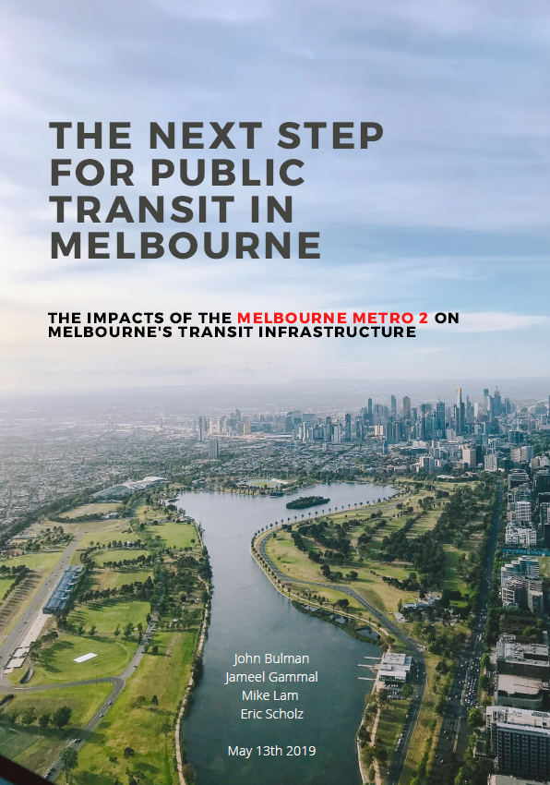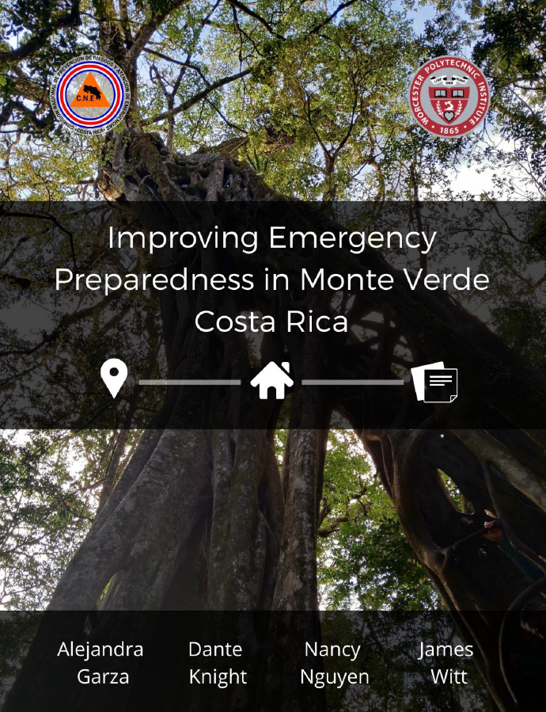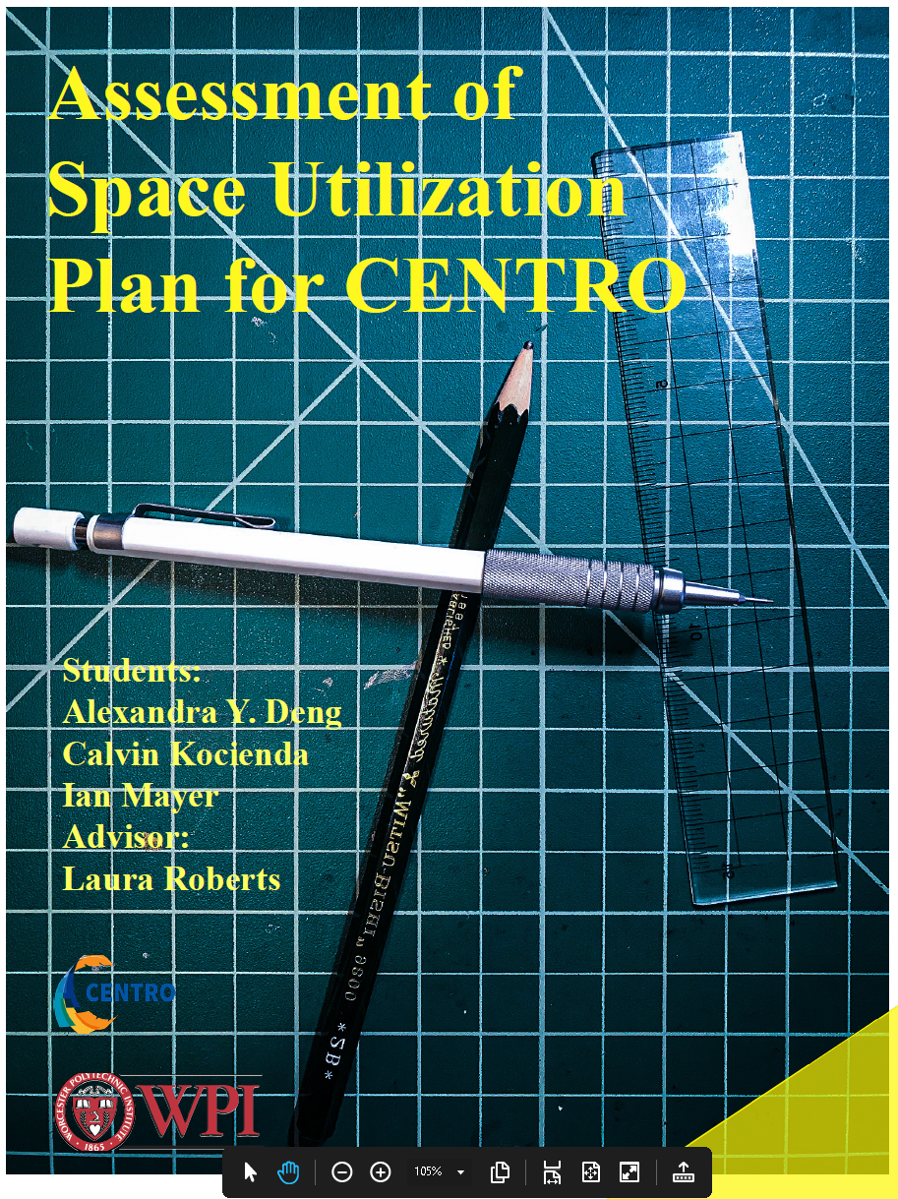

Appendix B: Required WPI Title Page for Final Report

Project Title

An Interactive Qualifying Project submitted to the Faculty of
WORCESTER POLYTECHNIC INSTITUTE
in partial fulfilment of the requirements for the degree of Bachelor of Science/Arts.

by
Author Name A
Author Name B
Author Name C

Date:
Day Month Year

Report Submitted to:

Sponsor Liaison(s)
Sponsoring Organization

Professors Name A and Name B
Worcester Polytechnic Institute

This report represents work of WPI undergraduate students submitted to the faculty as evidence of a degree requirement. WPI routinely publishes these reports on its web site without editorial or peer review. For more information about the projects program at WPI, see http://www.wpi.edu/Academics/Projects.

Appendix C: Example Final Report Authorship
Please note: Your Proposal should use an Authorship Table as described in section 4.2.
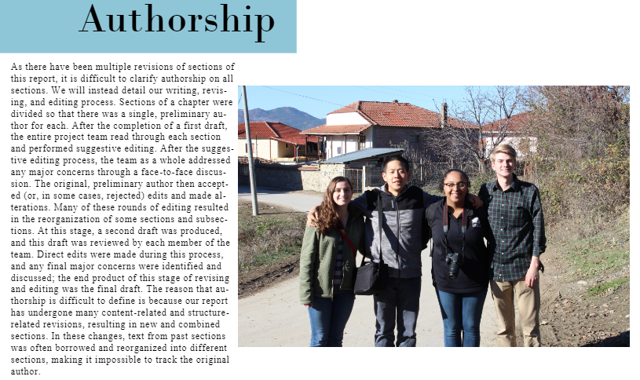

Appendix D: Example Meet the Team Pages

